Meeting with Dr. Kaipa
Time: 2:00-2:30
Location: Dr. Kaipa’s laboratory
- Next meeting:
  - Set up a meeting place in a conference room for next Thursday from 2:00 – 3:00.
  - Study all the components of the vehicle
- Front view drawing of existing vehicle

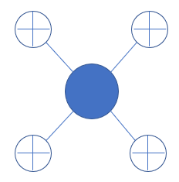

  - 4 thrusters for pitch and yaw motion
  - Brushless DC motors
    - Motors purchased from Blue Robotics in Canada
  - Vehicle was designed from scratch.
  - 3D printed in 4 parts
  - Main issues:
    - Waterproofing: 1 or 2 spoonfuls of water penetrated the inside of the vehicle after being under water for 45 minutes
    - Imperfect control system: 4 different potentiometers were used to control each thruster simultaneously
- Our goal: improve on existing vehicle
  - Improve waterproofing:
    - run tests to determine where water is permeating
      - Determine if water penetrates at specific places – consider partially submerging vehicle to test specific places
      - Determine if water penetrates only when vehicle collides with something
    - then implement seals
  - Improve control system: make a joystick based control
  - Minimize interior wiring
- Project scope: what can be done one year from now?
- Budget: Dr. Kaipa said we will determine that later as we determine what we need to purchase

