ODU FSAE Suspension Rockers Redesign and Implementation Using 3D-Printed Material


MAE 435
Instructor: Michael Polanco

Team leader:
Nakoma Austin
Team members:
Raio Lively
Sean Bryant
Charles Wilson
Jonas Nouchet

Advisor:
Dr. Ashish Tamhane

Table of Contents
Table of Contents ii
List of Figures iv
List of Tables v
List of Equations v
Abstract vi
Introduction 1
Background and Literature Review 3
Methods 8
Free Body Diagram of Vector Forces on the Front and Rear Rockers 8
Calculate the Sum of Moments for the Shock Resultant Force 12
Pre-Topology Linear Static Analysis 13
Topology Optimization 14
Calculating the Lateral Acceleration and Dynamic Forces 15
MTS 810 Machine Material Testing Plan 18
Fabrication and Set-Up of the MTS Machine 810 Test Rig 19
Printing of the PA6-CF 22
Engineering Standards 24
Results 27
Static Analysis 27
Pre-Topology Linear Static Analysis 28
Post-Topology Results 29
Dynamic Analysis 29
3D-Printing the Materials and the Fabrication of the Brackets 30
Discussion 32
Discussion of the Topology Figures in the Appendices 32
Comparison of the Pre- and Post-Topology Studies 34
Material Testing and Printing 35
Conclusion 38
References 40
Appendices 41
Appendix A: Contributions 41
Appendix B: Pre-Topology Linear Static Analysis 42
Appendix C: Post-Topology Results 48
Appendix D: MTS 810 Machine Brackets and Dimensions 56
Appendix E: Gantt Chart 62

List of Figures
Figure 1 – Rear Suspension Geometry Design 7
Figure 2 – Rear Wheel Free Body Diagram 8
Figure 3 – Rear Suspension Rocker Free Body Diagram (Dimensions Shown in Inches) 13
Figure 4 – Autocross (Left) and SkidPad (Right) Configurations 15
Figure 5 – MTS 810 Machine 20
Figure 6 – Rear Rocker Bracket Set-Up 21
Figure 7 – Markforged Mark Two 3D Printer 22
Figure 8 – PA6-CF Front Rocker Attached to the Vehicle 36

Figure B 1– Pre-Topology Front Rocker Stress Plot, Multi-Angle 42
Figure B 2 – Pre-Topology Rear Rocker Stress Plot, Multi-Angle 43
Figure B 3 – Pre-Topology Front Rocker Displacement Plot; [Left] Pre-Displacement; [Right] Post-Displacement 44
Figure B 4 – Pre-Topology Rear Rocker Displacement Plot; [Left] Pre-Displacement; [Right] Post-Displacement 44
Figure B 5 – Pre-Topology Front Rocker Factor of Safety Plot, Multi-Angle 45
Figure B 6 – Pre-Topology Rear Rocker Factor of Safety Plot, Multi-Angle 46
Figure B 7 – Mesh Settings 47

Figure C 1 – Post-Topology Front Rocker Stress Plot, Multi-Angle 48
Figure C 2 – Post-Topology Rear Rocker Stress Plot, Multi-Angle 49
Figure C 3 – Post-Topology Front Rocker Displacement Plot 50
Figure C 4 – Post-Topology Rear Rocker Displacement Plot 51
Figure C 5 – Post-Topology Front Rocker Factor of Safety Plot 52
Figure C 6 – Post-Topology Rear Rocker Factor of Safety Plot 53
Figure C 7 – Post-Topology Model Dimensions 54
Figure C 8 – Mesh Settings 55

Figure D 1 – Rear Rocker Test Bracket Set-Up 56
Figure D 2 – Front Rocker Test Bracket Set-Up 57
Figure D 3 – PA6-CF Rear Rocker with Brass Bearing 58
Figure D 4 – PA6-CF Front Rocker with Brass Bearing 59
Figure D 5 – Rear Rocker Bottom Bracket Dimensions 60
Figure D 6 – Rear Rocker Top Bracket Dimensions 60
Figure D 7 – Front Rocker Bottom Bracket Dimensions 61
Figure D 8 – Front Rocker Top Bracket Dimensions 61

Figure E 1 – Gant Chart Summer 2023 62
Figure E 2 – Gantt Chart Fall 2023 63

List of Tables
Table 1 – Rocker Weight Bias and Values 9
Table 2 – Push Rod and Shock Force Vectors 12
Table 3 – Rocker Weight Bias in SkidPad and Slaloms 17
Table 4 – Tire Weights in SkidPad and Slaloms 18
Table 6 – Results of the Static Force Analysis 27
Table 7 – Summary of the Pre-Topology Analysis 28
Table 8 – Summary of the Post-Topology Analysis 29
Table 9 – Summary of Forces in SkidPad 30
Table 10 – Summary of Forces in Slaloms 30

Table A 1 - Contributions 41

List of Equations
Equation 1) $tire force=total weight*left or right bias*forward or rear bias$ 9
Equation 2) $Fp=tire forcesin⁡(angle)$ 10
Equation 3) $Fs=Fp*rprs$ 12
Equation 4) $rSkidPad=15.252+32*39.3701 in=359.2695 in$ 16
Equation 5) $vSkidPad=2πrSkidPadtSkidPad*360063360$ 16
Equation 6) $aSkidPad=vSkidPad2rSkidPad$ 16
Equation 7) $blat SkidPad=aSkidPad386.4 ft-lbss2*12 in56 in$ 16
Equation 8) $Left Turning Bias=Left Bias-blat$ 16
Equation 9) $Right Turning Bias=Right Bias+blat$ 16
Equation 10) $rslaloms=7.622*39.3701 in=150.00732 in$ 17
Equation 11) $vslaloms=2πrslalomstslaloms*360063360$ 17
Equation 12) $aslaloms=vslaloms2rslaloms$ 17
Equation 13) $blat slaloms=aslaloms386.4 in-lbss2*12 in56 in$ 17
Equation 14) $frequency=1time to complete one cycle$ 19

Abstract
Every two years, Old Dominion University (ODU) produces a Formula Society of Automotive Engineers (FSAE) racing vehicle. In the production of this vehicle, student teams spend up to a year performing each step of the design process in order to build and compete with small formula-style racing cars. In the previous build of the ODU design team, both weight vehicle and cost were a concern as they successfully built a frame and suspension-rocker system out of aluminum. In the hopes of reducing both cost and weight, while maintaining desired safety standards, the team has proposed that new front and rear rockers be produced using 3D printing methods. Thus, an alternate plastic-based design has been explored with the goal of replacing the current aluminum rockers. The team has redesigned the rear suspension rockers through traditional static analyses and modern topology optimization. In the Fall 2023 semester, the team was able to 3D-print the rockers through the use of a Markforged Mark Two 3D Printer at ODU, but was unable conduct physical tests on the parts to further observe their performance capabilities in accordance with safety, cost, weight, and durability.

Introduction
From the 1980s forward, Old Dominion University (ODU) has produced and raced Formula SAE (FSAE) vehicles for competitions. It began with the Mini Indy competition, the precursor to FSAE, and now the team competes biannually each May in the international Society of Automotive Engineers (SAE) event held in Michigan [1]. In these events, the vehicles are subjected to a variety of static and dynamic events to ensure that the vehicle meets the design goals, however, this is not the only goal of the competition; according to the SAE website, students who participate in these events will experience aspects of the Engineering Design Process, such as: project management, team collaboration, application of industry rules and regulations, and the ability to develop and prepare technical documentation [2]. It is with these goals in mind that the Monarch Racing team continues to improve their existing FSAE design.
In years past, the vehicle has successfully been to competitions and back with no failures, but the Monarch Racing team needs a new method for manufacturing, optimizing, and designing the existing suspension and rocker system. In previous semesters, the rockers of the race car were made of aluminum; while this material provides desired Factor of Safety (FOS) ratings and exceeds minimum performance expectations, it is not yet possible to produce this part in the Additive Manufacturing (AM) Lab at ODU, resulting in higher costs to obtain this material from external vendors in addition to causing delays in project progress when it comes to the shipping times of this material. One other concern with the existing aluminum design is that of weight, which can negatively impact the vehicle as it relates to achieving desired speed specifications at the competitions.
In terms of vehicle functionality, the rockers serve to connect the frame of the vehicle to the damper and wheel strut; the wheel strut connects to the wheel, which supports the weight of the vehicle, and the damper cushions (or resists) the reactionary movements of the vehicle due to road surface disturbances. From a previous static analysis of the rockers through SolidWorks (Dassault Systèmes SOLIDWORKS Corp., Waltham, MA), it was discovered that the PA6-CF material would be able to safely sustain the maximum loading conditions while the vehicle is stationary. Using the optimized design that resulted from this analysis, the main goal of the Fall 2023 semester was to observe and improve the durability of the rockers through the collection of physical test data under cyclical loading conditions. It was anticipated that this goal would be accomplished using the Material Testing System (MTS) Machine as the primary test rig; additionally, the Project Board at ODU awarded $1500 for use in assembling additional testing equipment, as well as for covering the material and labor costs associated with acquiring the PA6-CF and employing the AM Lab to manufacture the rockers.

Background and Literature Review
As mentioned in the Introduction, there are two categories evaluated in the SAE racing events: Static Events and Dynamic Events. From the SAE Rules, the Static Events are defined as those events that do not rely on vehicle performance, such as the presentation and preparation of all materials relating to cost and design; in contrast, the Dynamic Events consist of an analysis of vehicle performance in five key areas: acceleration, skidpad, autocross, endurance, and efficiency [3].
First, in the Acceleration Event, the judges evaluate vehicle acceleration in a straight line on flat pavement [3]. In performing the test, each team is allowed two attempts at the course using two drivers, limited to two runs for each driver and priority is awarded to the first of those drivers; their goal is to accelerate as quickly as possible along a 75 m straight from the starting to finish line. The drivers perform in accordance with the following: 1) the foremost part of the vehicle is located 0.30 m behind the starting line, 2) the start of the run is indicated by a Green Flag or light signal, and (3) the timing starts when the vehicle crosses the starting line and ends when the vehicle crosses the finish line. In this event, there are two penalties, which occur if the vehicle makes contact with the cones on the course and if the vehicle runs off the course during the trial [3].
The second event is known as the Skidpad Event, which the Formula SAE Rules describe as a measure of the “vehicle cornering ability on a flat surface while making a constant radius turn” [3]. In this procedure, each team is allowed up to four runs, using two drivers, limited to two runs for each driver and the first driver has priority. The goal of this event is to demonstrate superior handling and maneuverability around two pairs of concentric circles shaped in a figure of eight. Performance of the event is as follows: 1) a Green Flag or light signal indicates approval to begin the run, 2) the vehicle enters perpendicular to the figure eight and will take one full lap on the right circle, 3) the second lap also occurs on the right circle and is timed, 4) the vehicle is to enter the left circle immediately upon completion of the second lap for the third lap, 5) the fourth lap takes place on the left circle and is timed, and (6) the vehicle exits the track immediately upon completion of the fourth lap moving in the same direction as it entered. In this event, penalties occur if the driver makes contact with the cones, if the vehicle runs off the course during the trial, and if the number of laps completed is incorrect or the performed in the wrong sequence [3].
Third is the Autocross Event, which evaluates the vehicle’s maneuverability and handling qualities on a tight course [3]. In this procedure, each driver may attempt up to four runs, using two drivers, limited to two runs for each driver and runs with the first driver have priority. For this event, the goal is to obtain average speeds between 40 kph and 48 kph along 0.80 km tracks that include straights, constant turns, hairpin turns, slaloms, and other miscellaneous turns. Performance of the event is as follows: 1) the vehicle is staged at a specific distance behind the starting line, 2) a Green Flag or light signal indicates approval to begin the run, and (3) timing starts when the vehicle crosses the starting line and ends when the vehicle crosses the finish line. For this portion of the Dynamic Events, penalties occur if the vehicle makes contact with the cones, if the vehicle runs off course during the trial, or if the vehicle misses one or more gates of a given slalom [3].
The fourth event is the Endurance Event, which evaluates the overall performance of the vehicle and tests its durability and reliability [3]. In this procedure, there are two drivers, and each team is allowed only one attempt; in particular, the event consists of two Endurance runs, each using a different driver and requiring a Driver Change in-between. The first driver performs in accordance with the following procedure: 1) a Green Flag or light signal indicates approval to begin the run, 2) the driver drives approximately half of the Endurance distance, 3) a checkered flag is then displayed, and (4) the vehicle exits the track into the Driver Change area. In the Driver Change area, there are restrictions involving the number of people allowed in the vicinity, two of whom must be drivers, and the only tools allowed in the area are those that assist with ensuring the vehicle accommodates the second driver as well as tools that assist with changing tires. During the Driver Change, the team is allowed three minutes to prepare and seat the second driver, who is then permitted to continue along the course until its completion. In the Endurance Event, penalties occur if the vehicle makes contact with the cones, if the vehicle runs off course during the trial, if a slalom is missed, if moving or post event violations occur in accordance with sections D.12.10 and D.14.12, and if the vehicle experiences any operation-related problems [3].
The final area of evaluation is referred to as the Efficiency Event, which evaluates the fuel, or energy, used to complete the Endurance Event [3]. For a vehicle to eligible for evaluation in this event, their (1) average Endurance lap time should not exceed 1.45 times the average Endurance lap time of the fastest team and (2) the corrected vehicle fuel consumption per lap must not exceed $\frac{26 liter}{100 km}$ or must not exceed the energy equivalent of 60.06 $\frac{kgCO_{2}}{km}$ per lap. In the procedure for evaluation in the Efficiency Event, the fuel tank must be filled to the fuel level line and there can be no shaking or tilting of the tank or vehicle during the fueling after it is filled to the scribe line. Unlike the previous events, this one does not possess any specific penalties, instead relying upon eligibility in order to evaluate the vehicle [3].
Continuing, each of these events contribute to the overall rating of the vehicle. It is the desire of the Monarch Racing team to achieve or exceed the evaluation criteria in each of the previous events. To obtain this goal, the team began optimizing the existing aluminum suspension and rocker system, which is comprised of dampers, push and pull rods, an anti-roll bar, the rockers, and double wishbones of equal length.
Mentioned previously, the role of the damper is to resist the compression of parts in the frame and wheels due to road surface disturbances; specifically, the vertical force experienced in the wheels is translated into horizontal motion on an anti-roll bar [4]. The anti-roll bar typically compliments designs that require higher roll stiffness and is applied to independent suspension systems and mounts to both ends of the lower suspension arms; it is constrained by mounts featured on the chassis, which allow rotation of the bar as the wheels oscillate up and down. Its purpose is to equalize the amount of force shared by the suspension system on each side of the car so that the car body does not roll as much when it is driving with a banking angle [4].
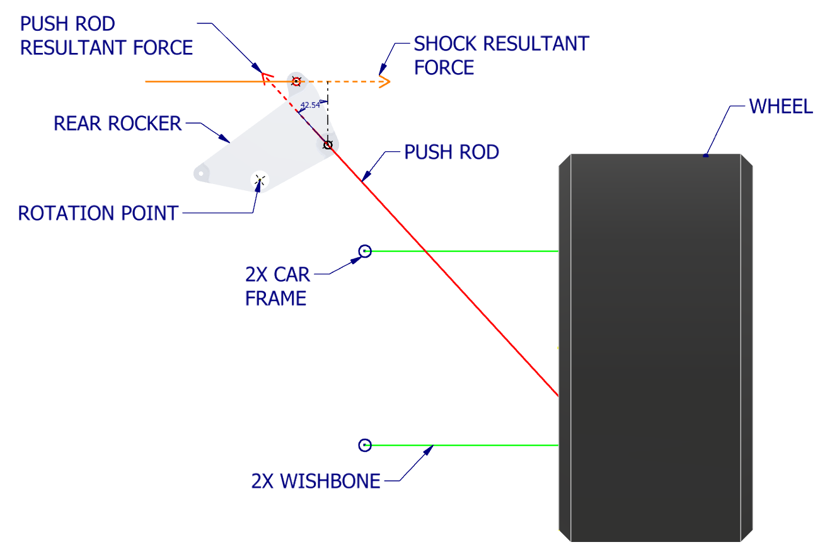
Figure 1 – Rear Suspension Geometry Design

Regarding the push and pull rods, their respective jobs are to translate motion experienced by the wheel as it incurs road surface disturbances [5]. Specifically, the pull rod experiences a disturbance and pulls the torsion spring, causing the rod to move up and outward from the chassis. The push rod, typically mounted higher than the pull rod, is mounted the opposite way and it works by pushing down and outward from the chassis. In both cases, the rod translates the motion to the rockers of the ODU FSAE race car. In the rear and front rockers, there is a push rod mounted to the chassis via a perfectly horizontal double wishbone of equal length.

Methods

Free Body Diagram of Vector Forces on the Front and Rear Rockers
In this project, the first step was to gain a sense of familiarity and understanding of the static forces that were acting upon the vehicle. The identified forces were the weight of the vehicle, the resultant force of the push rod going into the rocker, and the perpendicular distances from the force vectors to the origin (Figure 2). An additional force, the force of the shock on the rocker, was unknown due to a lack of supplier information.
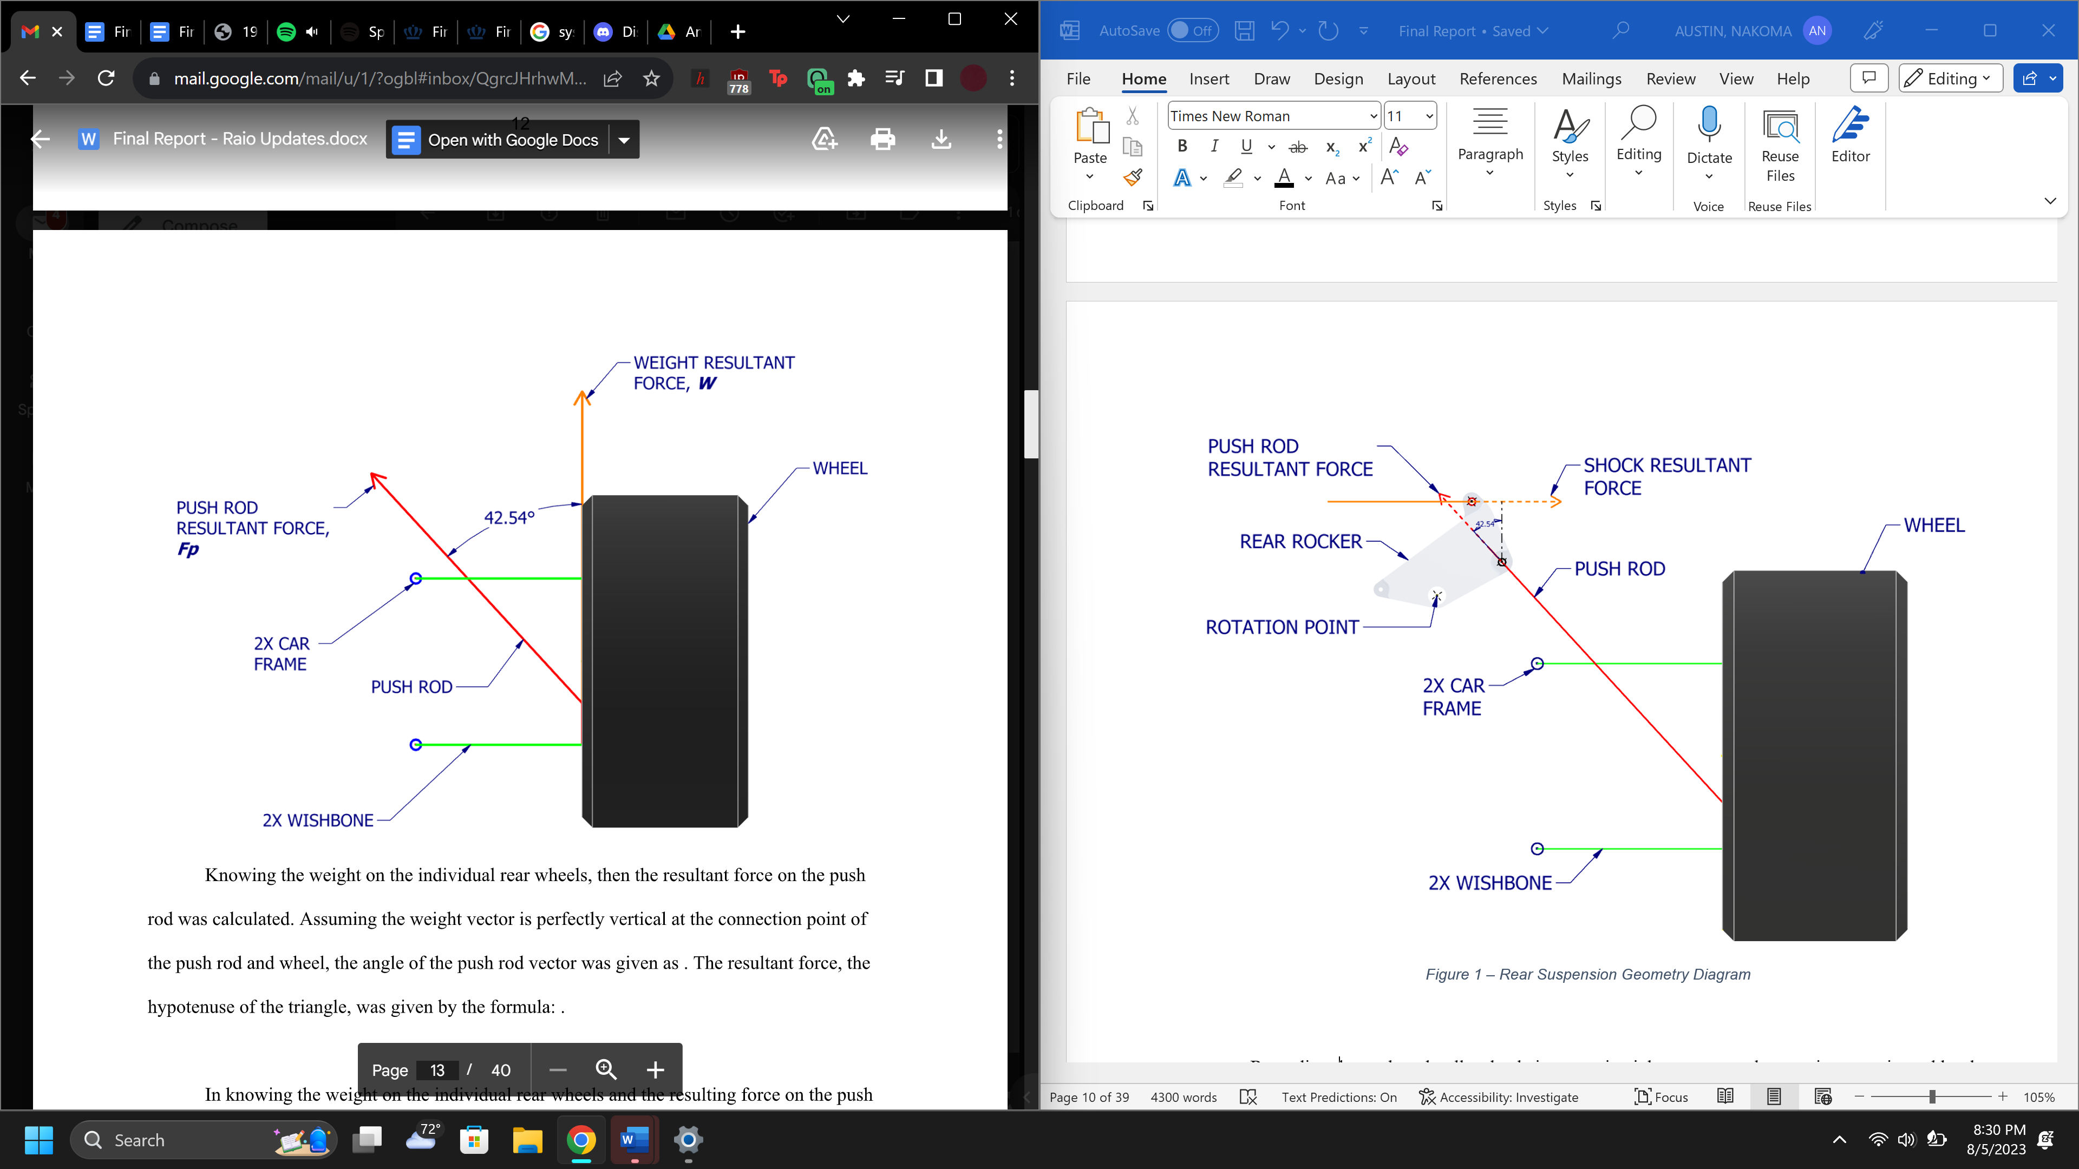
Figure 2 – Rear Wheel Free Body Diagram

It was discovered that the weight of the vehicle would be applied to the wheel strut, as the wheels are the only part of the vehicle that contacts the ground. From simulations ran on the former aluminum part, it was known that the total amount of weight that would need to be supported by the wheels, consisting of the driver and the vehicle, was 678 lbs. Listed in Table 1 below are the wheel weight distributions, which were used along with the Equation 1 to calculate the weight distributed to each individual wheel.

Equation 1) $tire force=total weight*\left(left or right\right) bias*\left(forward or rear bias\right)$

Table 1 – Rocker Weight Bias and Values
BIAS | PERCENTAGE (%)
Front | 50.6
Rear | 49.4
Left | 51.4
Right | 48.6

Next, the resultant force on the push rod was found using the calculated wheel weights. It was assumed that the weight vector was perfectly vertical at the connection point of the push rod and wheel, and so the resulting angles of the push rod vector were given as ${42.54}^{o}$ for the rear rockers and ${66.25}^{o}$ for the front rockers. The resultant push rod force, the hypotenuse of the triangle, was given by Equation 2.

Equation 2) $F_{p}=\frac{tire force}{sin⁡(angle)}$

In knowing the weight on the individual wheels and the resulting forces on the push rod, the next calculation was for the perpendicular distances from the force vectors to the origin. These calculations were performed by assigning the origin point to the large hole, where the rocker attaches to the frame and pivots about that point. It was then assumed that the force vector from the shock was perfectly horizontal and pointing to the left. Using SolidWorks, the perpendicular distance from the origin to the push rod vector $\left(r_{p}\right)$ and the perpendicular distance from the origin to the shock vector $\left(r_{s}\right)$ were found and are summarized in
Table 2.

Table 2 – Push Rod and Shock Force Vectors
WHEEL | PUSH ROD VECTOR (in) | SHOCK VECTOR (in)
Front Right (FR) | 1.9678 | 1.9497
Front Left (FL) | 1.9678 | 1.9497
Rear Right (RR) | 2.6861 | 3.6866
Rear Left (RL) | 2.6861 | 3.6866

Calculate the Sum of Moments for the Shock Resultant Force
To solve for the shock resultant force, it was assumed that the rotation in the clockwise direction would be positive. The four variables were declared as $F_{s}=Shock Force$, $F_{p}=Push Rod Force$, $r_{p}=perpendicular distance of the push rod$, and
$r_{s}=perpendicular shock distance$; these results are contained in Table 3 of the Results section and the formula used to find the shock vector was Equation 3.

Equation 3) $F_{s}=F_{p}*\left(\frac{r_{p}}{r_{s}}\right)$

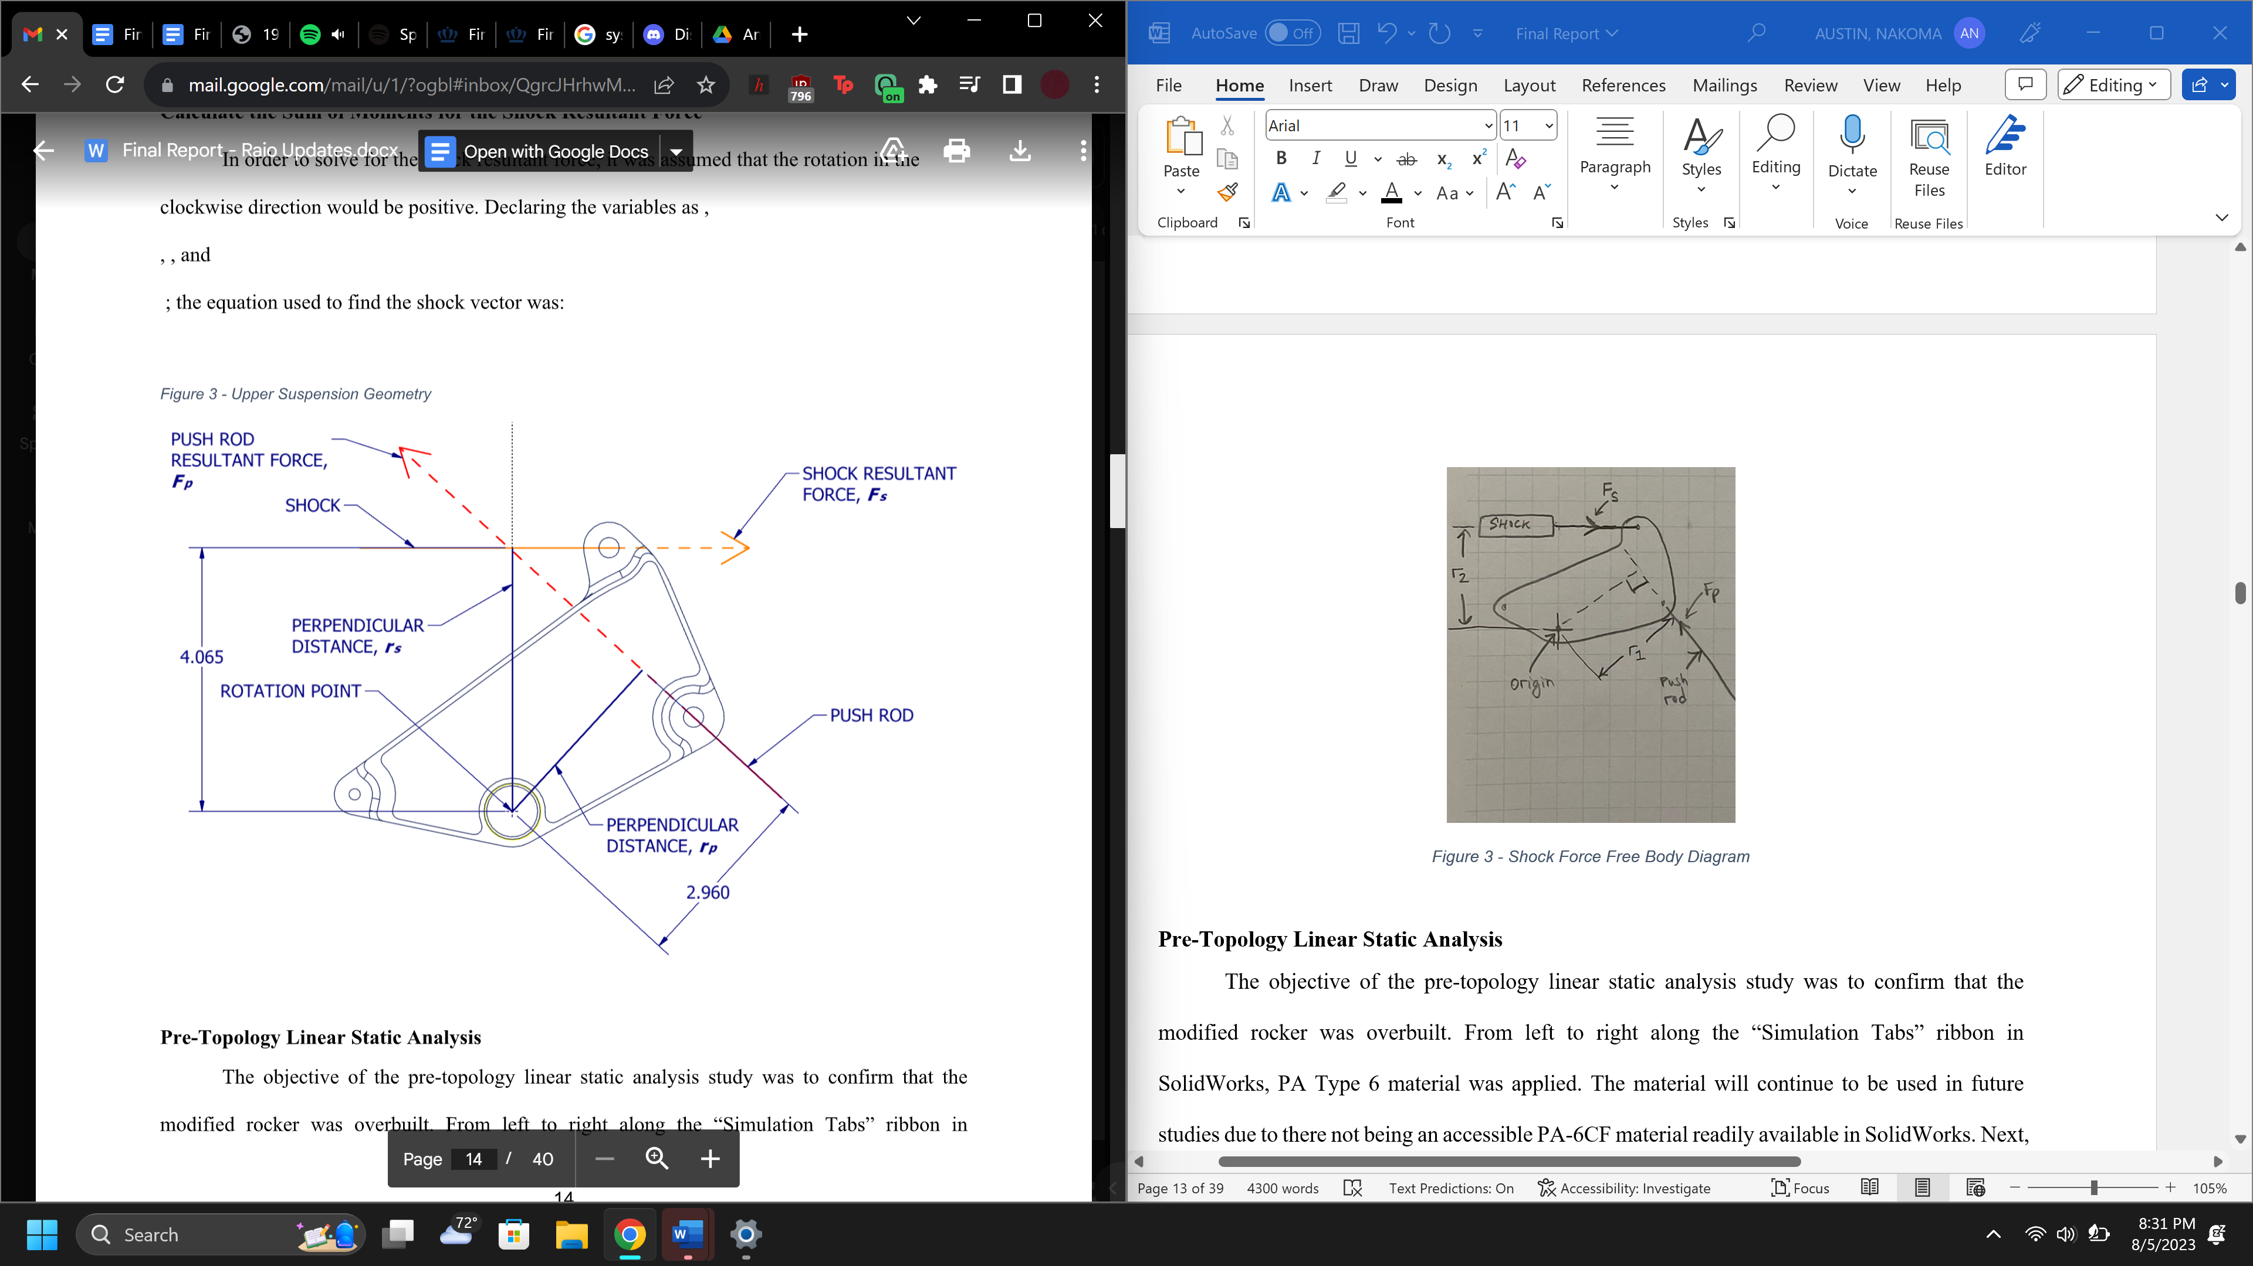
Figure 3 – Rear Suspension Rocker Free Body Diagram (Dimensions Shown in Inches)

Pre-Topology Linear Static Analysis
The objective of the pre-topology linear static analysis study was to evaluate the structural integrity of the modified rockers. From left to right along the “Simulation Tabs” ribbon in SolidWorks, PA Type 6 material was applied. It is important to note that this PA Type 6 material is an estimated basis for the design of the rockers and will be corrected to PA6-CF before the parts are able to be manufactured; it was utilized due to time constraints and limitations imposed by SolidWorks, as the PA6-CF material is not listed in the software details and would require the manual input of material specifications that are presently under evaluation. Next, a fixed “fixture” was applied to the three cylindrical faces of the large hole of the rocker; this is the attachment point to the frame and must be considered as fixed for the analysis to run. On the vehicle, this “fixed fixture” would be a fixed hinge, so this consideration was for the purpose of the simulation only. Continuing, a bearing load was applied along the push rod vector to the inside cylindrical faces of the push rod attachment holes. The bearing load was chosen because the forces were distributed in a parabolic fashion over the hole faces, with the same being performed for the shock attachment holes along the shock axis. Then, to prevent stress concentrations from developing along the mesh lines, the mesh settings were changed to “High” with local mesh controls, which further refined the meses inside the holes. The study was then performed with the settings shown in the figures found in Appendix B.

Topology Optimization
A topology optimization study uses the results of a stress analysis to determine the locations of unnecessary material in a part, which would serve to reduce material costs and the mass of the object of study. The criteria and settings of the pre-topology stress analysis above were transferred into the topology study; the fixture, loads, and mesh settings were kept the same. The goals and constraints chosen were “Best Stiffness to Weight Ratio,” with a mass reduction goal of 50%. Additionally, a preserved region was chosen on all exterior faces, except for the large flat sides, which had a depth of $5 mm.$To further supplement future motion studies, a $7.5 mm$ thick rib was added to the topology optimized part. In doing so, the newly designed part was subjected to a linear static analysis using the criteria from the pre-topology analysis. Finally, the study was conducted with the settings configuration shown in Figure C8.

Calculating the Lateral Acceleration and Dynamic Forces
To prepare for testing, the lateral acceleration of the vehicle needed to be calculated to understand the force distribution on the rockers as the vehicle made turns. In simple terms, lateral acceleration is the acceleration in the direction opposite to the travel path of the vehicle; when turning in a circle, the lateral acceleration causes a centrifugal force that acts outward from the radius of the turn [6]. In this analysis, the SkidPad and slaloms portion of the Autocross track (Figure 4) were analyzed, using footage of the ODU FSAE racing vehicle from the 2022 competition.

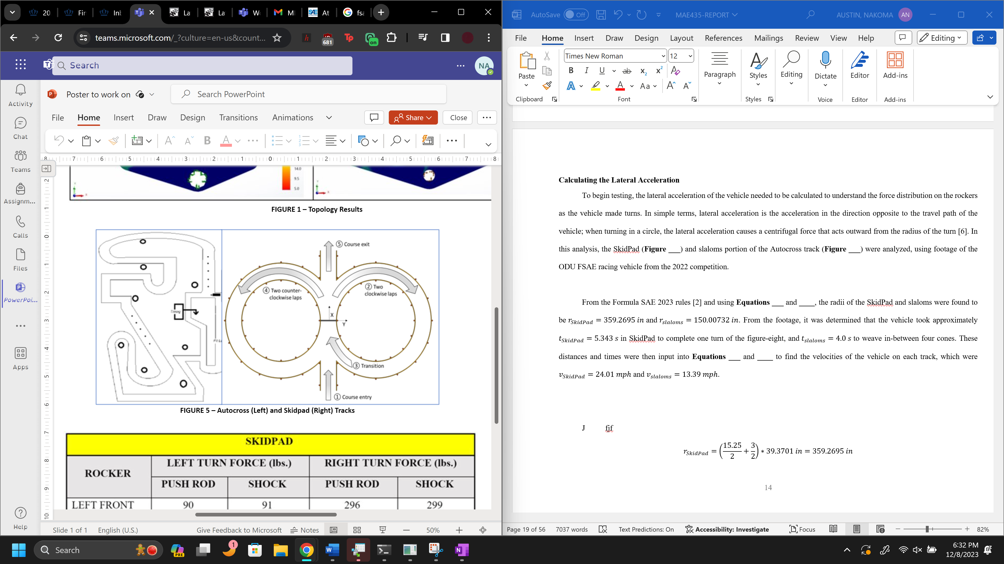
Figure 4 – Autocross (Left) and SkidPad (Right) Configurations

From the footage of the previous racing vehicle, it was determined that it took approximately $t_{SkidPad}=5.343 s$ to complete one turn in the figure-eight of the SkidPad track. In knowing the time, the next item needed was the radius of the turn. Found in the Formula SAE 2023 rules [2] and using Equation 4, the radius of the figure-eight turn was found to be $r_{SkidPad}=359.2695 in$. Then, using Equation 5 to calculate the velocity of the vehicle $(v_{SkidPad})$ and Equation 6 to calculate the acceleration in the turn $\left(a_{SkidPad}\right)$, the bias of the vehicle in SkidPad $(b_{lat SkidPad})$ was found using Equation 7, which was then used to calculate the left and right turning bias from Equations 8 and 9; from the resulting values, the tire weights could then be determined from Equation 1.

Equation 4) $r_{SkidPad}=\left(\frac{15.25}{2}+\frac{3}{2}\right)*39.3701 in=359.2695 in$
Equation 5) $v_{SkidPad}=\frac{2πr_{SkidPad}}{t_{SkidPad}}*\frac{3600}{63360}$
Equation 6) $a_{SkidPad}=\frac{v_{SkidPad}^{2}}{r_{SkidPad}}$
Equation 7) $b_{lat SkidPad}=\frac{a_{SkidPad}}{386.4 \frac{ft-lbs}{s^{2}}}*\frac{12 in}{56 in}$
Equation 8) $Left Turning Bias=Left Bias-b_{lat}$
Equation 9) $Right Turning Bias=Right Bias+b_{lat}$

Similarly, the footage of the previous racing vehicle revealed that the time required to traverse in-between four cones equally placed at distances of $7.62 m$ from each other in the Autocross track was $t_{slaloms}=4.0 s$. In using Equation 10, the radius of each slalom turn in this track was approximately $r_{slaloms}=150.00732 in$. Then, Equation 11 was used to calculate the velocity of the race car ${(v}_{slaloms})$and Equation 12 was used to calculate the acceleration ($a_{slaloms})$, and the weight bias in the slaloms ${(b}_{lat slaloms})$was approximated using Equations 13, which was then used to calculate the left and right turning bias from Equations 8 and 9; from the resulting values, the tire weights were then determined from Equation 1. Below, in Table 3, these biases are summarized alongside the ones found for the SkidPad calculations.

Equation 10) $r_{slaloms}=\frac{7.62}{2}*39.3701 in=150.00732 in$
Equation 11) $v_{slaloms}=\frac{2πr_{slaloms}}{t_{slaloms}}*\frac{3600}{63360}$
Equation 12) $a_{slaloms}=\frac{v_{slaloms}^{2}}{r_{slaloms}}$
Equation 13) $b_{lat slaloms}=\frac{a_{slaloms}}{386.4 \frac{in-lbs}{s^{2}}}*\frac{12 in}{56 in}$

Table 3 – Rocker Weight Bias in SkidPad and Slaloms
 | PERCENTAGE (%)
BIAS | SKIDPAD | SLOLAMS
Front | 50.6 | 50.6
Rear | 49.4 | 49.4
Left | 23.84 | 30.87
Right | 76.16 | 69.13

As performed in the static analysis, the rocker weight biases were input into Equation 1 to find the force experienced on each tire. Below, in Table 4, is a summary of the tire forces experienced in both SkidPad and the slaloms in Autocross for both left and right turns. Equations 2 and 3 were used, alongside the push rod $(r_{p})$ and shock vector $(r_{s})$ values from Table 2, to calculate the forces on the push rod $\left(F_{p}\right)$ and shock $(F_{s})$ in dynamic loading. Like the sum of moments calculations performed for the static analysis, the clockwise direction was once again assumed to be positive. The values found for the push rod and shock vectors are contained in Tables 9 and 10 of the Results section.

Table 4 – Tire Weights in SkidPad and Slaloms
 | SKIDPAD TIRE WEIGHTS (lbs.) |  | SLALOMS TIRE WEIGHTS (lbs.)
WHEEL | LEFT TURN | LEFT TURN | LEFT TURN | RIGHT TURN
Front Right (FR) | 261.30 | 237.18 | 237.18 | 96.28
Front Left (FL) | 81.77 | 105.89 | 105.89 | 246.79
Rear Right (RR) | 255.10 | 231.55 | 231.55 | 94.00
Rear Left (RL) | 79.83 | 103.38 | 103.38 | 240.93

MTS 810 Machine Material Testing Plan
After finding the dynamic force distribution on the SkidPad and Autocross tracks, a test plan for fatigue cycle analysis was then formulated. In the test plan, it was conservatively assumed that the vehicle would undergo no more than 52 test drives a year on the tracks, which would imply at least one test drive per week.
In conjunction with the FSAE 2023 rules [3], a complete cycle in the SkidPad portion was assumed to be two left turns and two right turns on the track. From the time found in the footage of the previous vehicle, this would equate to a total time of $21.372 s$ to complete one cycle. Therefore, over the course of one year, the race car would make a total of 104 right-turns and 104 left-turns. This results in a frequency of $0.04679\frac{cycles}{s}$ (Equation 14), or $1112 s$ in one year.

Equation 14) $frequency=\frac{1}{time to complete one cycle}$

For the slaloms in Autocross, the composition of the track adjusts each year and so it was assumed that the harshest scenario would be a total of eight equally distanced cones. To traverse eight cones, the footage reveals that the race car would need $8.0 s$ to complete this cycle, but that it would be more accurate to assume that the vehicle would perform four sets of cycles in a test session (or four sets of eight cones in one session); thus, one test session would occur over the course of $32 s$. The resulting frequency, using Equation 14, was $0.0125 s$ for a total of 208 cycles, or $1664 s$ in one year.

Fabrication and Set-Up of the MTS Machine 810 Test Rig
For the MTS Machine model 810 (Figure 5), test brackets had to be created for the front and rear rockers to set them into the machine. These parts were manufactured in the ODU Motor Sports Lab using two welding methods and a $24x36 in$ sheet of hot-rolled mild steel. The first method was Tungsten Inert Gas (TIG) welding, which is a form of arc welding that uses a non-consumable tungsten electrode to produce the weld. The second method Shielded Metal Arc welding, informally referred to as STICK welding, which uses a consumable electrode covered with a flux to lay the weld.
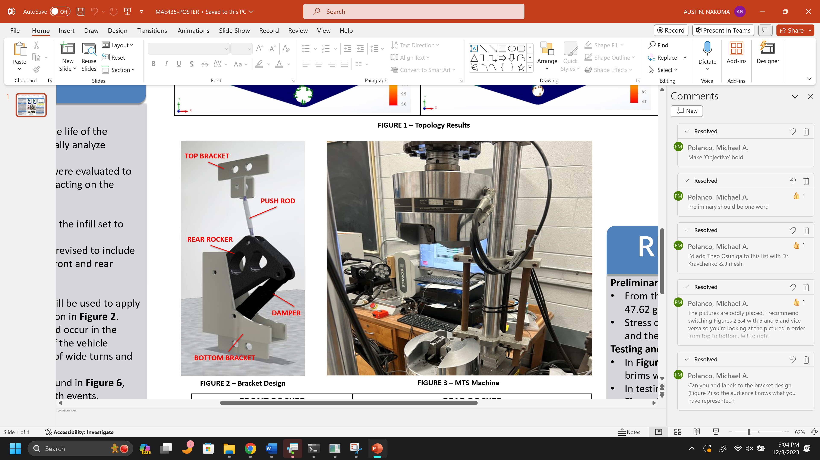
Figure 5 – MTS 810 Machine

Found in Appendix D are the bracket designs with dimensions. Below, in Figure 6, is the model for how the rear rocker was configured into the MTS 810 Machine. For the rear rocker, the mild steel push rod affixed to the test rig was $10.5 in$, and the push rod attached to the front rocker was $14 in$. Additionally, it is important to note that the Motor Sports Lab also machined brass bearings to affix the front and rear rockers to their respective push rods and shocks as well. The shocks and rocker of the bottom bracket were bolted to the MTS Machine using M8 bolts, with two in the shock and one on the rocker; the push rod was connected to the MTS Machine using one 5/16 bolt to mount to the top bracket and one to connect the push rod to the rocker. In the test, the vertical forces mentioned in Tables 9 and 10 of the Results section acting on the push rod and the shock would force the rocker into the shock, causing a cycle of compression and release in the shock for the respective cycles mentioned in the MTS 810 Machine Testing Plan.
Figure 6 – Rear Rocker Bracket Set-Up

Printing of the PA6-CF
In brief, 3D printing is the process of making three dimensional objects from a digital file using an additive process, or a process that creates an object by laying down successive layers of a material until the desired object is made [7]. For the rockers, a Markforged Mark Two 3D Printer (Figure 7) was available for use, which uses Eiger software (Markforged, Waltham, MA) to optimize part design, set the infill amount, and control the layering of the print. In particular, one key feature of this printer that made it optimal for the project is its ability to reliably print objects at high temperatures without the need for a temperature-controlled bed for minimizing material warping.

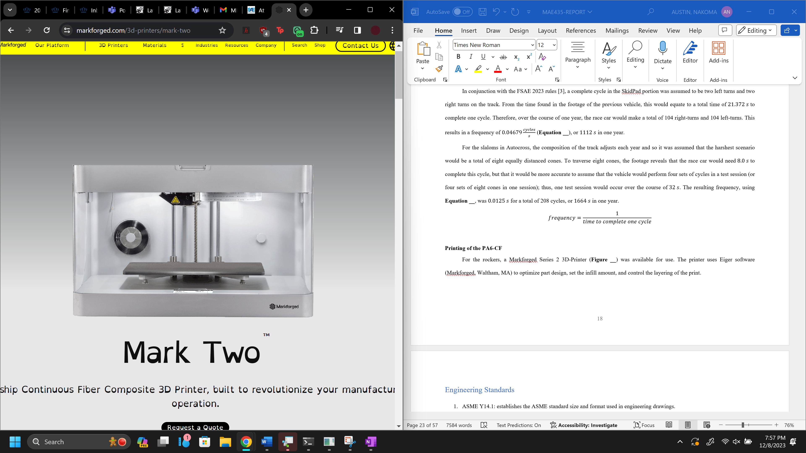
Figure 7 – Markforged Mark Two 3D Printer

For the project, the material utilized was Onyx™ PA6-CF, which was the brand suggested and used by the manufacturers of the Markforged Mark Two 3D Printer. Using Eiger, the infill was set to 100% with a layer thickness of $0.2 mm$ in order to print two sets of front and rear rockers at ${295}^{o}F$. To prevent warping, brims were added to the face of the rockers that were in contact with the printer bed, which had a thickness of $0.2 mm$ for the front rockers and $1.0 mm$ for the rear rockers; additionally, Elmer’s Washable Stick Glue was applied to the surface of the bed to ensure that the material would adhere and further prevent warping.

Engineering Standards
- ASME Y14.1: establishes the ASME standard size and format used in engineering drawings.
In the project, ASME Y14.1 will be utilized to format the engineering drawings that will be sent to the AM Lab as the final design to be printed.
- ASME Y14.2: lists accepted line conventions and letterings used on engineering drawings.​
In the project, ASME Y14.2 will be utilized to establish uniform letterings and line conventions of all the engineering drawings that will be sent to the AM Lab as the final design to be printed.
- ASME Y14.3M: lists accepted forms of single, multiple, and sectional views used on engineering drawings.
​In the project, ASME Y14.3M will be utilized to ensure the uniformity of the engineering drawings submitted to the AM Lab as they relate to sectional views of the front and rear rockers; its use is critical in that it will allow the drawings to be interpreted more quickly and efficiently, while displaying all of the necessary dimensions.
- ASME Y14.100: provides a list of standard requirements and reference documents needed in the revision of engineering drawings.
In the project, ASME Y14.100 was utilized in the revision of the engineering drawings associated with the front and rear rockers produced by the rocker redesign team in the Summer 2023 semester; these revised drawings were used to find the new masses of the rockers, stress analysis, and displacement analysis resulting from the Topology Optimization.
- ASME Y14.35: establishes the practice for revising drawings and associated documentation and demonstrates methods for identification and revisions. ​
In this project, ASME Y14.35 was utilized in the revision of the documented results found in the Summer 2023 semester; this documentation includes the Static Analysis, Post-Topology Results, and the images found in Appendix C of the report.
- ISO 9001: international standard that specifies requirements for a quality management system.​
In this project, ISO 9001 is utilized in the following forms: project transparency, with all project documentation and communication documented on a public website; a customer-oriented focus, where the customer and the team have open lines of communication and meet on a weekly basis to provide updates of the project, receive direct feedback in relation to the work performed, and continuously improve upon existing ideas to further adapt them to meet customer needs.
- ASME Y14.5: establishes the rules, symbols, definitions, requirements, defaults, and recommended practices for stating and interpreting Geometric Dimensions and Tolerances on engineering drawings, models defined in digital data files, and related documents.​
In the project, ASME Y14.5 was utilized in the initial interpretation of the models and drawings including the original aluminum specifications; the standard will continue to be utilized when submitting the new designs to the AM Lab for printing to ensure that project needs are met.
- ASTM-E606: details the determination of fatigue properties in marginally homogeneous materials subjected to strain-controlled cyclic loading. ​
In the project, ASTM-E606 will be utilized in the creation of the testing criteria for and observance of the rockers under cyclical loading conditions.
- ASTM-B438: specifies requirements of bronze-based bearings produced from mixed metal powders using powder metallurgy technology and then impregnated with oil to supply lubrication.​
In the project, ASTM-B438 will be utilized to ensure that the rocker-suspension design is optimized for the replacement of the hinges connecting the rockers to the push rod with bronze-based bearings.

Results

Static Analysis
The results for the static analysis are summarized in Table 6 below. The weight of the individual wheels, using the weight biases listed in Table 1, were: $W_{FR}≈167 lbs, W_{FL}≈176 lbs, W_{RR}≈163 lbs$ and $W_{RL}≈172 lbs$; these values sum to provide the total vehicle and driver weight of $W_{Total}=678 lbs$. It was then, using these weights, that the push rod forces were calculated, providing the following set of values from the rear and front angles of ${42.54}^{o}$ and ${66.25}^{o}$: $F_{p (FR)}≈182 lbs, { F}_{p \left(FL\right)}≈193 lbs, F_{p (RR)}≈241 lbs$ and $F_{p (RL)}≈255 lbs$. From SolidWorks, the perpendicular distances between the push rod $\left(r_{p}\right)$ and shock $(r_{s})$ from the origin were: $r_{p (rear)}=2.6861 in$, $r_{p (front)}=1.9678 in$, $r_{s (rear)}=3.6866 in$, and $r_{s (front)}=1.9497 in$. Finally, the shock forces resulting from the sum of moments were found to be: $F_{s (FR)}≈184 lbs, F_{s \left(FL\right)}≈194 lbs, F_{p (RR)}≈175 lbs$ and $F_{p (RL)}≈186 lbs$.

Table 5 – Results of the Static Force Analysis
WHEEL | PUSH ROD VECTOR (in) | SHOCK VECTOR (in) | WEIGHT (lbs.) | SHOCK FORCE (lbs.) | PUSH ROD FORCE (lbs.)
Front Right (FR) | 1.9678 | 1.9497 | 166.73 | 183.85 | 182.16
Front Left (FL) | 1.9678 | 1.9497 | 176.34 | 194.45 | 192.66
Rear Right (RR) | 2.6861 | 3.6866 | 162.78 | 175.43 | 240.77
Rear Left (RL) | 2.6861 | 3.6866 | 172.16 | 185.53 | 254.64

Pre-Topology Linear Static Analysis
For the pre-topology linear static analysis, three main items were observed and recorded for comparison with the post-topology results: the stress analysis plot, the displacement plot, and the factor of safety plot. These results can be found in Appendix B. For the front rockers, the results were: maximum stress of $σ_{f-PRE}=2.0 ksi$, minimum factor of safety $(FO{S)}_{f-PRE}=7.7$, and a maximum displacement of $ϵ_{f-PRE}=0.003 in$ located at the damper attachment holes. Similarly, the rear rockers were also weakest at the hole connecting the rocker to the dampers, resulting in the following values: maximum stress $σ_{r-PRE}=3.0 ksi$, minimum factor of safety $(FO{S)}_{r-PRE}=5.0$, and a maximum displacement of $ϵ_{r-PRE}=0.010 in$. The resulting masses of the PA6 front and rear rockers were found to be $m_{f-PRE}=166.00 g$ and $m_{r-PRE}=126.65 g$, respectively. For convenience, these values are summarized in Table 7 below.

Table 6 – Summary of the Pre-Topology Analysis
ROCKER | MAXIMUM STRESS $σ$ (ksi) | MINIMUM FOS | MAXIMUM DISPLACEMENT $ϵ$ (in) | Mass (g)
Front | 2.0 | 7.7 | 0.003 | 166.00
Rear | 3.0 | 5.0 | 0.010 | 126.65

Post-Topology Results
In the same way, the post-topology linear static analysis observed the same three features as the pre-topology analysis, resulting in the figures located in Appendix C. For the front rocker, the following values were obtained upon the conclusion of the study: maximum stress of $σ_{f-POST}=4.40 ksi$, minimum factor of safety $(FO{S)}_{f-POST}=2.20$, and a maximum displacement of $ϵ_{f-POST}=0.006 in$ located at the damper attachment holes. The rear rockers were also weakest at the hole connecting the rocker to the dampers, resulting in the following values: maximum stress $σ_{r-POST}=3.958 ksi$, minimum factor of safety $(FO{S)}_{r-POST}=2.481$, and a maximum displacement of $ϵ_{r-POST}=0.008 in$. For this analysis, SolidWorks determined that the optimized masses for the front and rear rockers would be $m_{f-POST}=47.62 g$ and $m_{r-POST}=160.19 g$. For convenience, these results are summarized below in Table 8.

Table 7 – Summary of the Post-Topology Analysis
ROCKER | MAXIMUM STRESS $σ$ (ksi) | MINIMUM FOS | MAXIMUM DISPLACEMENT $ϵ$ (in) | Mass (g)
Front | 4.4 | 2.2 | 0.006 | 47.62
Rear | 3.958 | 2.481 | 0.008 | 160.19

Dynamic Analysis
From the calculations, the results of the forces on the push rod and shock are summarized below in Tables 9 and 10. For a left turn in SkidPad, the following values were obtained: $F_{p-SP (LT-LF)}= 90 lbs$, $F_{p-SP (LT-LR)}= 119 lbs$, $F_{s-SP (LT-LF)}= 91 lbs$, and $F_{s-SP (LT-LR)}= 87 lbs$; and for a right turn: $F_{p-SP (RT-LF)}= 296 lbs$, $F_{p-SP (RT-LR)}= 392 lbs$, $F_{s-SP (RT-LF)}= 299 lbs$, and $F_{s-AC (RT-LR)}= 286 lbs$. For a left turn in the Autocross slaloms, the results were: $F_{p-AC (LT-LF)}= 116 lbs$, $F_{p-AC (LT-LR)}= 153 lbs$, $F_{s-AC (LT-LF)}= 117 lbs$, and $F_{s-AC (LT-LR)}= 112 lbs$; and for a right turn: $F_{p-AC (RT-LF)}= 270 lbs$, $F_{p-AC (RT-LR)}= 357 lbs$, $F_{s-AC (RT-LF)}= 273 lbs$, and $F_{s-AC (RT-LR)}= 260 lbs$.

Table 8 – Summary of Forces in SkidPad
ROCKER | LEFT TURN FORCE (lbs.) |  | RIGHT TURN FORCE (lbs.)
 | PUSH ROD | SHOCK | PUSH ROD | SHOCK
LEFT FRONT | 90 | 91 | 296 | 299
LEFT REAR | 119 | 87 | 392 | 286

Table 9 – Summary of Forces in Slaloms
ROCKER | LEFT TURN FORCE (lbs.) |  | RIGHT TURN FORCE (lbs.)
 | PUSH ROD | SHOCK | PUSH ROD | SHOCK
LEFT FRONT | 116 | 117 | 270 | 273
LEFT REAR | 153 | 112 | 357 | 260

3D-Printing the Materials and the Fabrication of the Brackets
In Figures D1 and D2 are the completed brackets for the rear and front rockers. The brackets for the front rockers were longer than the ones for the rear rockers, because the push rod for the front rockers was $14 in$, while the push rod for the rear rockers was only $10.5 in$. The basic dimensions of the brackets can be found in Appendix D.
In Figures D3 and D4 are the 3D-printed PA6-CF front and rear rocker with the brass bearings inserted. The surface around the edges of the prints were rough due to the manual filing of the prints, which was performed using a metal chisel. These parts were made using the Markforged Mark Two 3D Printer and Onyx™ PA6-CF filament at 100% infill and a layer thickness of $0.2 mm$. The final masses of these rockers, without the bearings, were $48.43 g$ for the front rocker and $152.36 g$ for the rear rocker.

Discussion
The purpose of the project was to design, simulate, manufacture, and test new rockers that could be 3D-printed in the Additive Manufacturing (AM) Lab at Old Dominion University (ODU). Ideally, these new rockers would be more readily accessible and inexpensive than the previous aluminum rockers, which were manufactured by a vendor off-campus; such delays in the shipping of the aluminum parts further contributed to the desirability of a material design that could be manufactured and tested on-site at the campus. From the static analysis and topology studies, the aim was to simulate PA6-CF rockers that would have a total weight reduction of 50% of the previous aluminum set and maintain, or exceed, a design Factor of Safety (FOS) of 2. Furthermore, from the results of the testing, the goal was to ascertain the reliability of the printer to manufacture rockers of the same quality for each print, as well as to quantify the average life cycle of the rockers in fatigue conditions.

Discussion of the Topology Figures in the Appendices
For both the pre-topology and post-topology studies, a summary of the results is contained in Tables 7 and 8; however, these numerical values were obtained from the figures listed in Appendix B and Appendix C. Contained in these appendices are images that display various color-related scales, which are used to distinguish between regions of high and low: stress, factors of safety, and displacement.
In Figures B1, B2, C1, and C2 are the results of the pre- and post-topology analyses of the stress; on these scales, the blue regions indicate areas of minimum stress, and the red regions indicate the maximum stress areas. It can be seen in all figures listed that, for both the front and rear rockers, the largest stress region occurs where the rockers attach to the dampers and the push rods.
In Figures B3, B4, C3, and C4 are the results of the displacement analyses; on these scales, blue indicates regions of the least amount of displacement and red regions indicate significant areas of displacement. For the front rockers, in both studies, the holes where the part attaches to the damper and push rod undergo significant displacement, with the most displacement occurring at the damper connection. On the other hand, for the rear rockers in both studies, the area that experienced the maximum displacement was very clearly indicated by a bright red located at the hole connecting the rocker to the damper.
In Figures B5, B6, C5, and C6 are the results of the factor of safety analyses; on these scales, blue indicates that a region has a high FOS, whereas red indicates that that area experiences the lowest FOS. In the pre-topology study for the front and rear rockers, the lowest factors of safety occur at the holes where the parts attach to the damper. Similarly, in the post-topology study rear rockers, this same region experiences the smallest FOS; however, the post-topology front rockers have substantially more red areas than their pre-topology counterparts. In particular, the post-topology front rockers experience low factors of safety around the fillets where the mass of the rocker was cut by the simulation, in addition to experiencing the lowest FOS at the hole where the damper connection is located.

Comparison of the Pre- and Post-Topology Studies
From the values produced in the pre-topology study in Table 7 and the post-topology study in Table 8, two conclusions can be made: 1) the topology analysis was justified and the results were meaningful and (2) the customer requirements were satisfactorily achieved.
In particular, the necessity of the topology analysis was proven by the conservative values produced in the pre-topology study. In the pre-topology analysis, before optimizing the parts for mass, the front and rear rockers had masses of $m_{f-PRE}=166.00 g$ and $m_{r-PRE}=126.65 g$; using these masses and not allowing the system to optimize the part, the lowest factor of safety occurred in the rear rocker with $(FO{S)}_{r-PRE}=5.0$, while the lowest value of the front rocker was $(FO{S)}_{f-PRE}=7.7$. Examining these factors of safety in relation to the desired minimum requirement of $FOS≥2$ shows that the part was overbuilt for the specifications currently desired by the customer and, thus, could afford to undergo a weight reduction at the expense of a $ΔFOS=±3$ of those values. From the topology analysis, with the goal of reducing the masses to 50% of the pre-topology values, the post-topology masses were found to be $m_{f-POST}=47.62 g$ and $m_{r-POST}=160.19 g$; these masses resulted in factor of safety values of $(FO{S)}_{f-POST}=2.20$ in the front rocker and $(FO{S)}_{r-POST}=2.481$ in the rear rocker.
Examining these results further, it was determined that the mass of the front rocker was reduced to 29.73% of the pre-topology value, while the mass of the rear rocker increased by 126.48% of the original mass. In terms of the original mass reduction goal, the front rocker was able to exceed the desired specifications, while the rear rocker appeared to become worse than before. Due to time constraints that occurred during this study, the customer concluded that the results of the rear rocker were acceptable for the purpose of the project scope at that time, which focused more on the safety aspect of the parts as opposed to the mass reduction; it was then requested that the topology analysis of the rear rocker be revisited before the physical testing was to begin, because the results of a reduction in mass would conserve the project budget and, ultimately, improve the performance of the vehicle in future competitions.

Material Testing and Printing
Unfortunately, due to limited staffing resources and training opportunities, the rockers were never able to make it to the MTS 810 Machine. This piece of equipment requires formal training in order to be operated with regards to fatigue cycle testing, which will be accounted for in future work on the project. The ODU Project Board, as well as the faculty advisor on this project, have been advised of this limitation and have been directed to the online training presented on the MTS website. Regardless, the calculations for the test plan were completed and so the cycles listed in the MTS 810 Machine Testing Plan and the forces in Tables 9 and 10 will be used on future work to estimate the fatigue life of both front and rear rockers. Additionally, testing should begin as soon as the next group of students is familiar with the project, as all brackets have been created and the bearings and fixings needed to adhere them to the rockers, MTS Machine, push rods, and shocks are ready as well.
Despite having no test results, one of the original goals of the project was successfully achieved: to see if the PA6-CF rockers could support the weight of the vehicle. In Figure 8 below, there is an image of the front rockers attached to the vehicle. The weight on that test was approximately $480 lbs$, as there was no driver in the seat. Regarding the effectiveness of the rear rockers, the parts did manage to fit on the vehicle, but the fillet where the shock connected to the top of the rocker was too shallow and so it was deemed unsafe to test the vehicle weight on the rear rockers. Additionally, the goal of decreasing the weight of the rockers was achieved in the front rocker but was not achieved for the rear rocker. From the Post Topology Results, the estimated weights of the front and rear rockers were $47.62 g$ and $160.19 g$, respectively. After 3D printing the rockers, the final weights were $48.43 g$ for the front ($1.7\%$ increase from the topology study) and $152.36 g$ for the rear ($4.89\%$ decrease from the topology study). Compared to the original front and rear weights of the rockers, $166.0 g$ and $126.65 g$, the manufactured ones were a $70.83\%$ decrease and $20.28\%$ increase from the originals.

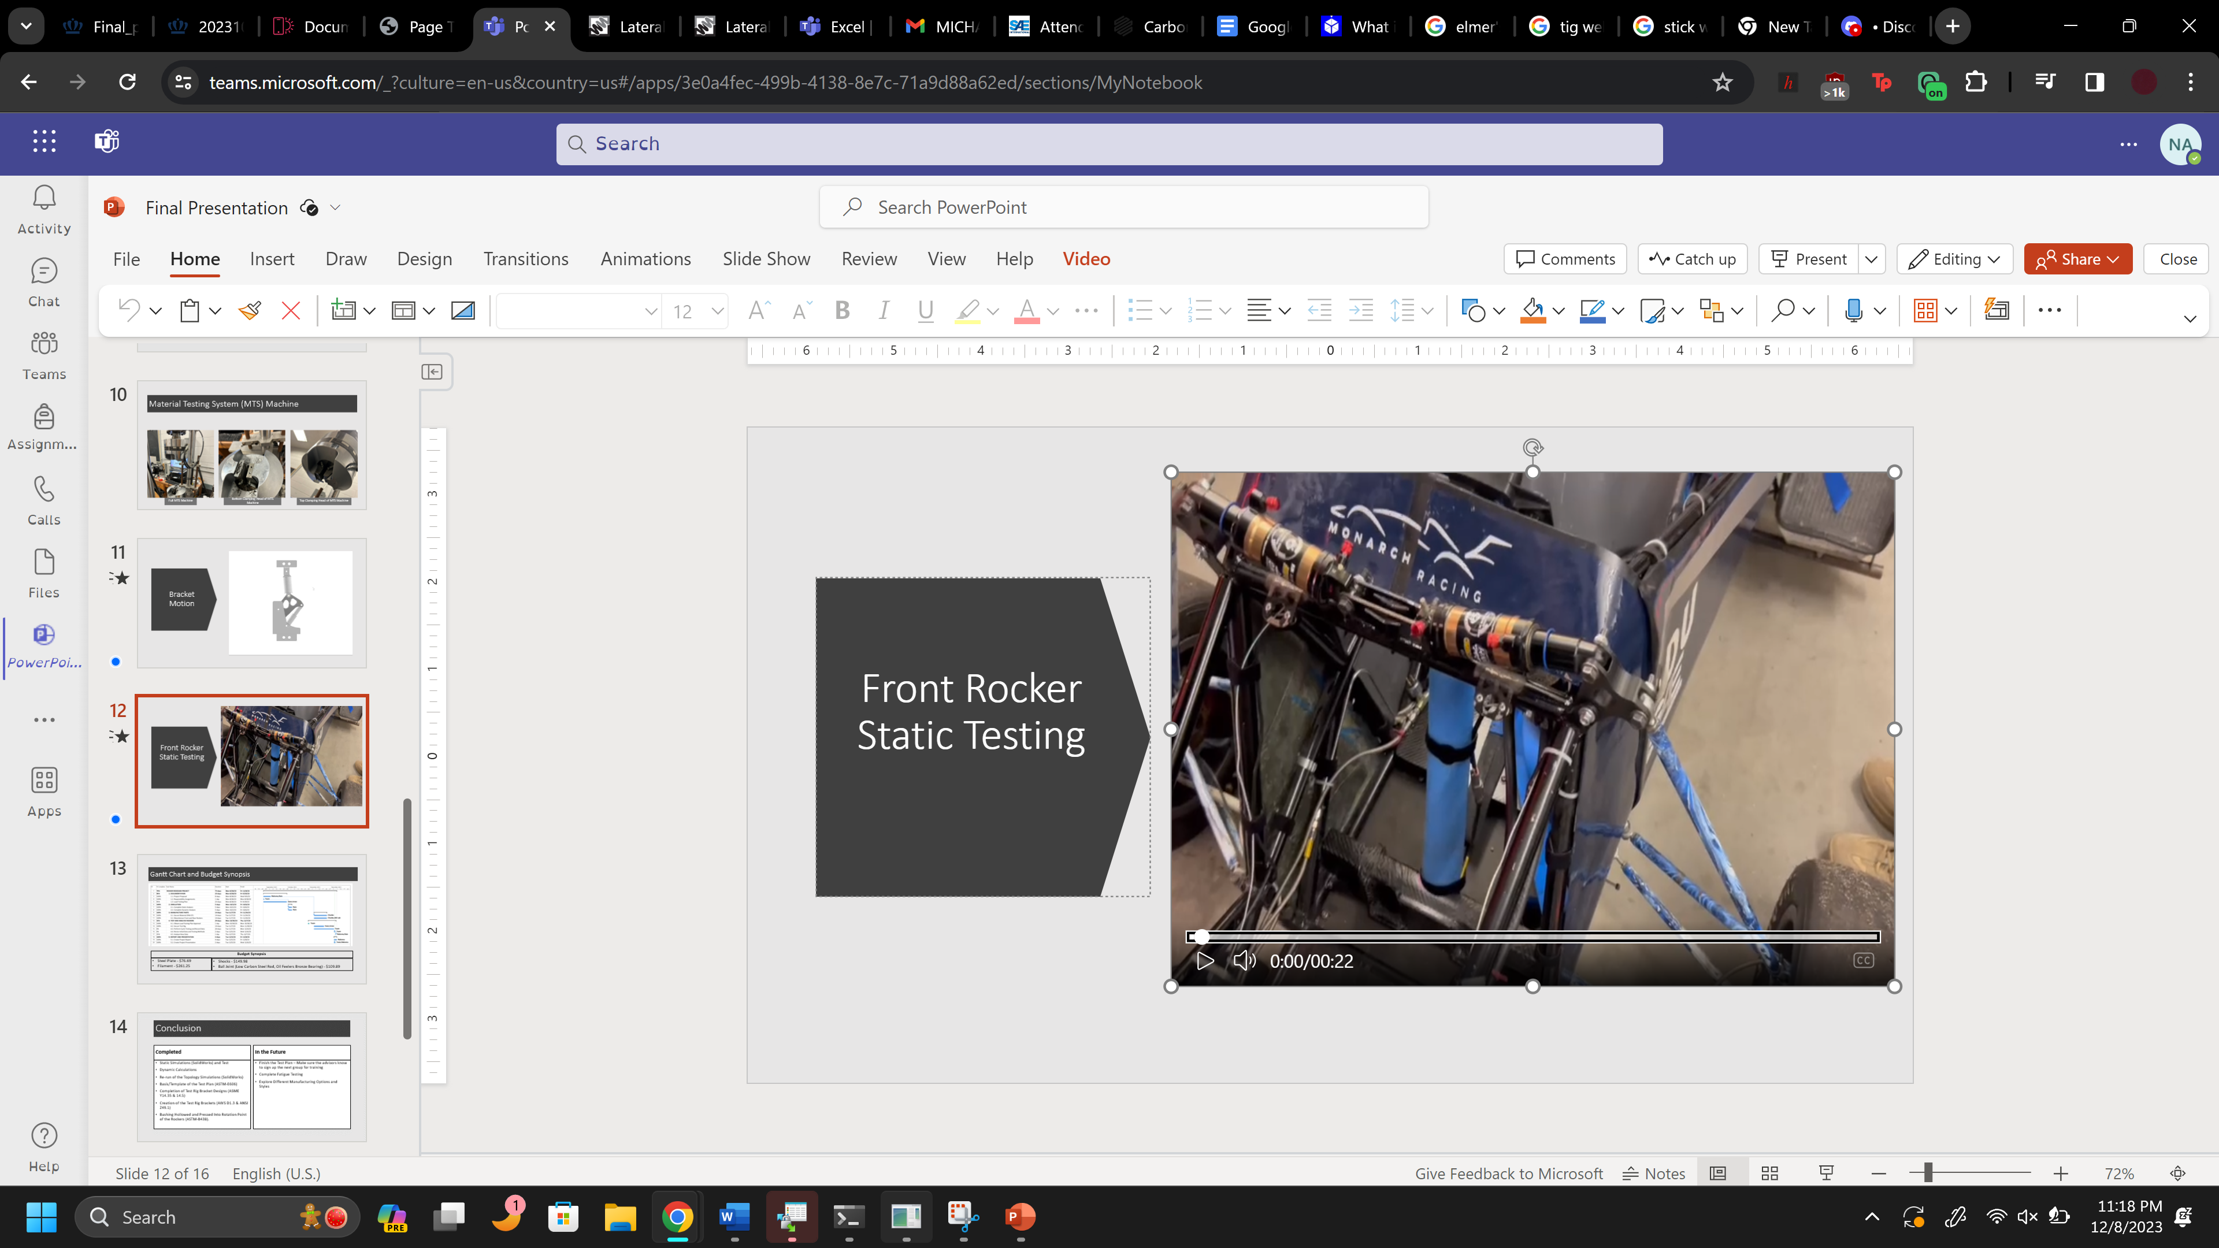
Figure 8 – PA6-CF Front Rocker Attached to the Vehicle

Looking toward the future, in addition to testing, project groups will also have the freedom to change the printing method and study the affects of infill, and other manufacturing methods, on the durability of the rockers. Primarily, the FSAE Team has an interest in studying the effects of annealing on the rockers, as well as the durability of a PA6-CF rocker that is manufactured using a continuous carbon fiber filament. Since there is no research yet on these areas of manufacturing, the primary goal of the future team will be to improve the strength and durability of the manufactured rockers created in Fall 2023 semester by applying different material strengthening methods, and collect data on the mechanical properties of the PA6-CF material.

Conclusion
The Old Dominion University (ODU) Formula Society of Automotive Engineers (FSAE) team produces a race car every two years and competes at the national level. It is upon their request that a study has been undertaken to explore the viability of 3D-printing and manufacturing the front and rear rockers of the vehicle, as opposed to continuing the use of the existing aluminum parts. This study focuses on: reducing the masses of the parts for improved performance of the vehicle during competition while maintaining a factor of safety (FOS) that is $FOS≥2.0$; manufacturing the rockers on-campus at ODU in order to decrease costs associated with commissioning the manufacture of the aluminum parts by outside vendors, whom also halt project progress through unpredictable shipping times; and designing and conducting physical testing of the rockers using the Material Testing System (MTS) to collect data for static, dynamic, cyclic, and impact loading conditions.
To determine the optimization of the part in terms of mass reduction, a topology analysis was performed in SolidWorks using PA6 material in place of PA6-CF material due to software limitations and time constraints that occurred during the Summer 2023 semester. In a topology analysis, an optimization study is performed that uses the results of a stress analysis, along with AI, to determine the locations of unnecessary material in a part. From the results of the pre-topology study, it was determined that the initial design of the rockers was overbuilt due to the large values for the factors of safety, which justified the need for a complete topology optimization analysis; thus, the topology study was conducted with the goal of reducing the mass of the front and rear rockers to 50% of the pre-topology mass, while maintaining a factor of safety (FOS) value of $FOS≥2.0$. The final masses resulting from the study were $m_{f-POST}=47.62 g$ and $m_{r-POST}=160.19 g$, with respective safety factors of $(FO{S)}_{f-POST}=2.2$ and $(FO{S)}_{r-POST}=2.481$.
From the results of the topology study, it was concluded that the new design was sufficient to serve as a foundation for an improved topology design using a PA6-CF specification sheet and inputting those material values into SolidWorks to run the topology study using the same mass reduction and factors of safety criteria as before. The customer accepted the results of the previous topology design, which served to exceed the minimum factor of safety requirement $FOS≥2.0$ for both the front and rear rockers, exceeded the desired 50% mass reduction in the front rocker to 29.73% of the original, but failed to meet the mass reduction criteria for the rear rocker due to a 126.48% increase in mass resulting from the emphasis on maintaining a high FOS.
From the results of the printed part, it was proven that the printed PA6-CF front rockers were able to withstand the weight of the vehicle. Moreover, the mass reduction in the front rocker of $48.43 g$was $70.83\%$ from the original, while the increase in mass of the rear rocker of $152.36 g$ was $20.28\%$ from the original. Thus, the team was successfully able to decrease the mass of the front rocker but not the rear rocker. Additionally, while testing was not able to be performed this semester, a fatigue cycle test plan for the MTS 810 Machine was completed, along with the brackets necessary to set up the test rig, and can be used in the future to obtain results on the mechanical properties of the rockers, and future work is expected to explore the changes in material strength due to annealing, the implementation of continuous carbon fiber reinforcement, and varying infills.

References

[1] | "Monarch Racing," Old Dominion University, [Online]. Available: https://sites.wp.odu.edu/monarch-racing/. [Accessed 1 August 2023].
[2] | "SAE International," SAE International, 2023. [Online]. Available: https://www.sae.org/attend/student-events/formula-sae-knowledge/learning-objectives. [Accessed 1 August 2023].
[3] | "Formula SAE Rules 2023," 7 November 2022. [Online]. Available: file:///C:/Users/nlana/Downloads/FSAE_Rules_2023_V2.pdf. [Accessed 4 August 2022].
[4] | J. A. Farrington, "Redesign of an FSAE Race Car's Steering and Suspension System," University of Southern Queensland Faculty of Engineering and Sureveying, 2011.
[5] | S. Kanal, "Formula1," 13 April 2023. [Online]. Available: https://www.formula1.com/en/latest/article.explainer-whats-the-difference-between-pull-rod-and-push-rod-suspension.1I3wL4LEL0nQZbKZbx1Dhz.html#:~:text=When%20a%20tyre%20goes%20over,lower%20on%20the%20wheel%20assembly.. [Accessed 4 August 2023].
[6] | "Suspension Secrets," 2019. [Online]. Available: https://suspensionsecrets.co.uk/lateral-and-longitudinal-load-transfer/. [Accessed 8 December 2023].
[7] | "3D PRINTING," 2023. [Online]. Available: https://3dprinting.com/what-is-3d-printing/. [Accessed 8 December 2023].
[8] | Engineering Drawing Practices, ASME, 2017.
[9] | "MatWeb," 2023. [Online]. Available: https://www.matweb.com/search/DataSheet.aspx?MatGUID=3b7912a327fc46adae8d97ba8c2c21ea&ckck=1. [Accessed 4 August 2023].
[10] | "MatWeb," 2023. [Online]. Available: https://www.matweb.com/search/DataSheet.aspx?MatGUID=fb48404b7e04433bb3ee3d2a0af922ff. [Accessed 4 August 2023].
[11] | W. F. Milliken and D. L. Milliken, Race Car Vehicle Dynamics, Warrendale: Society of Automotive Engineers, Inc, 1995.

Appendices

Appendix A: Contributions
Table A 1 – Contributions
CONTRIBUTOR | CONTRIBUTION(S)
Nakoma Austin | Table of Contents, List of Figures, List of Tables, Discussion, and Appendices
Raio Lively | Methods and Results
Charles Wilson | Background/Literature Review and Engineering Standards
Jonas Nouchet | Conclusion and Abstract
Sean Bryant | Introduction and References

Appendix B: Pre-Topology Linear Static Analysis
Figure B 1– Pre-Topology Front Rocker Stress Plot, Multi-Angle
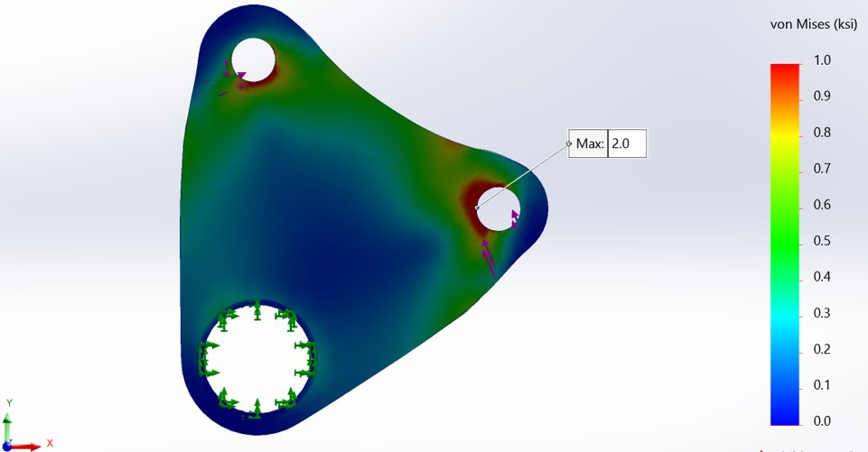 | 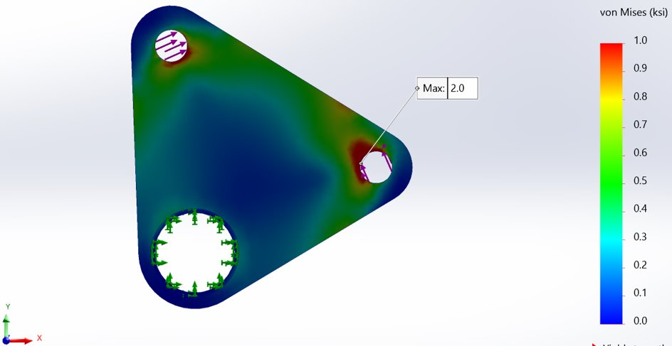
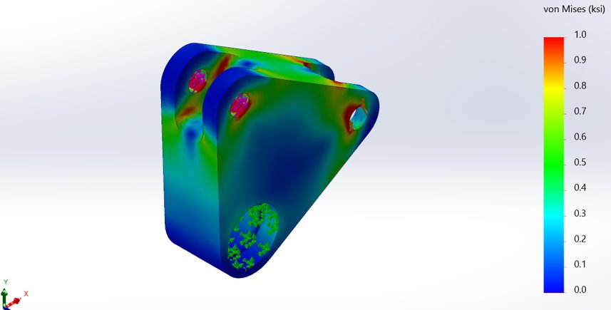 | 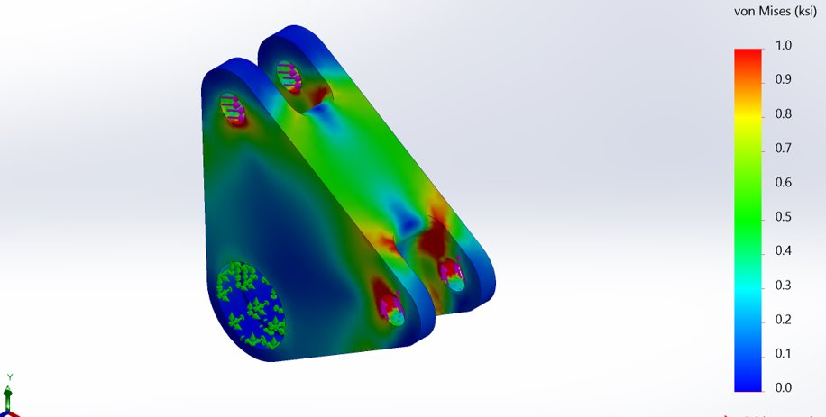

Figure B 2 – Pre-Topology Rear Rocker Stress Plot, Multi-Angle
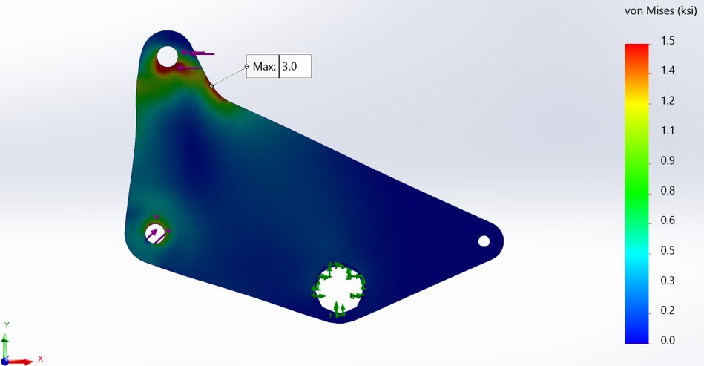 | 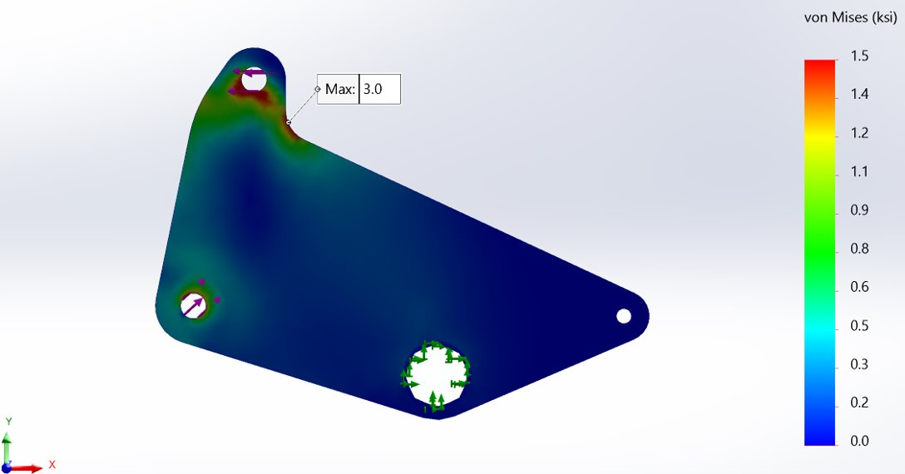
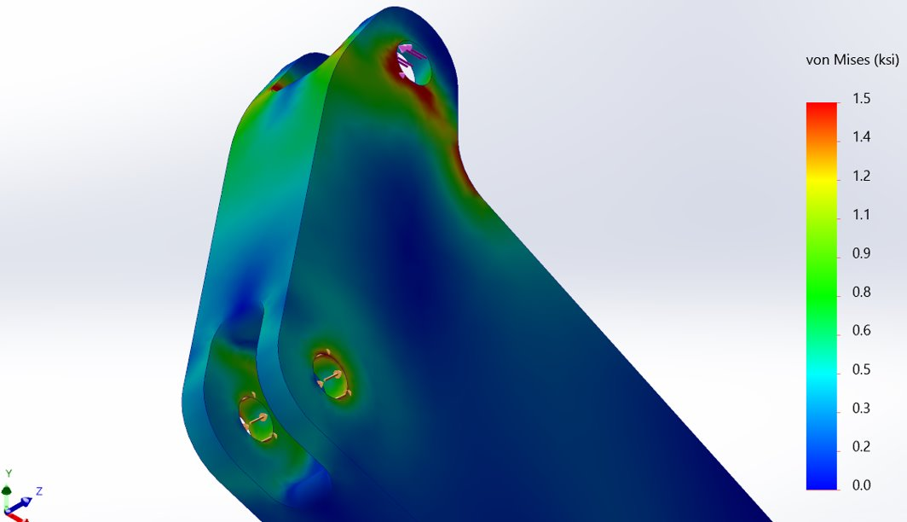 | 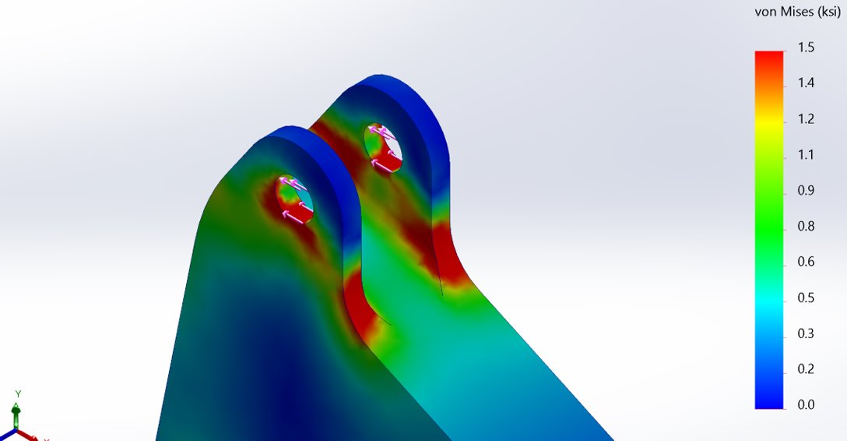

Figure B 3 – Pre-Topology Front Rocker Displacement Plot; [Left] Pre-Displacement; [Right] Post-Displacement
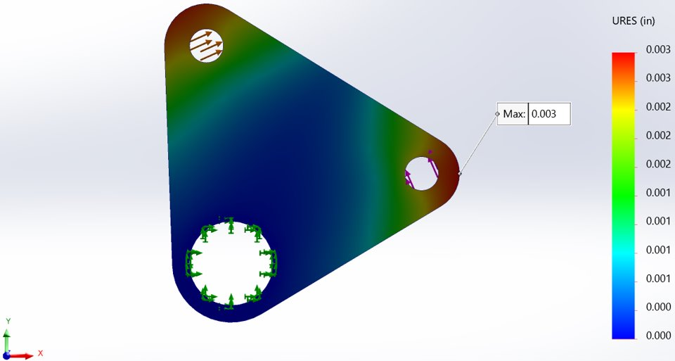 | 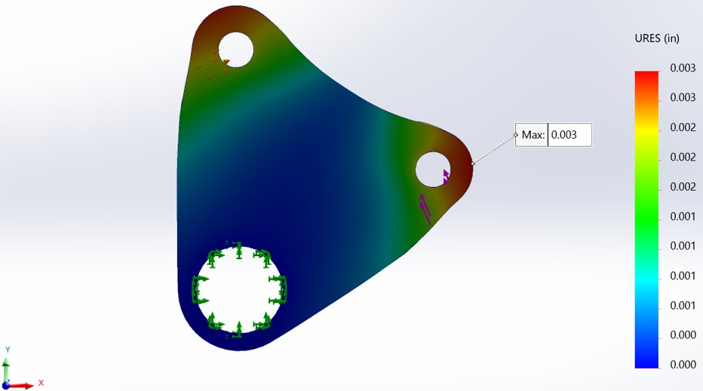

Figure B 4 – Pre-Topology Rear Rocker Displacement Plot; [Left] Pre-Displacement; [Right] Post-Displacement
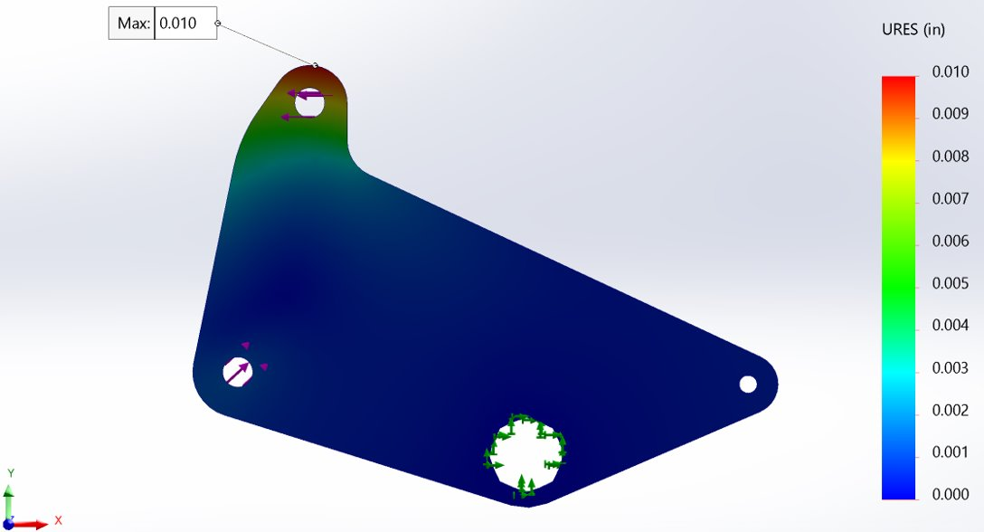 | 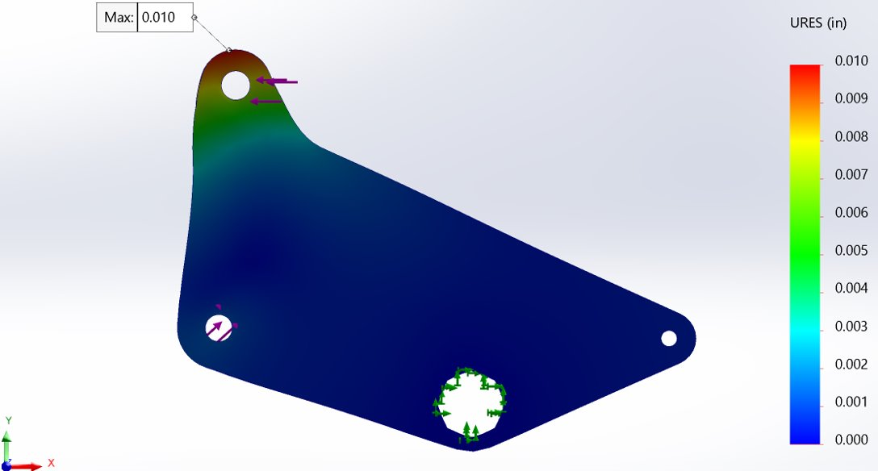

Figure B 5 – Pre-Topology Front Rocker Factor of Safety Plot, Multi-Angle
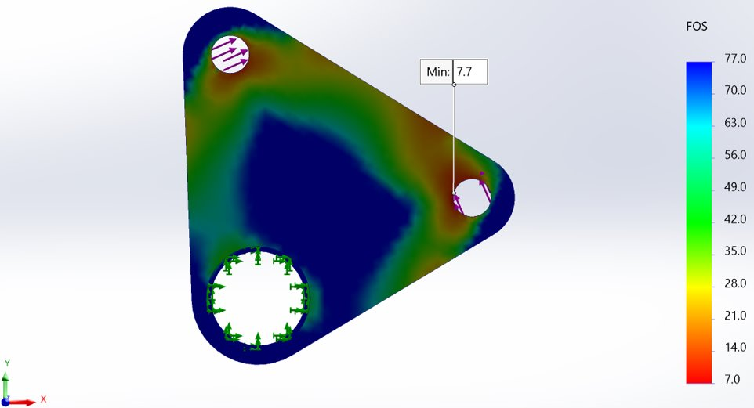
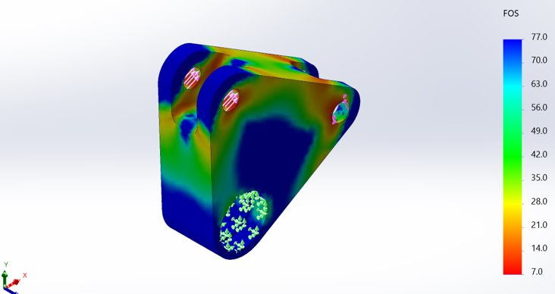 | 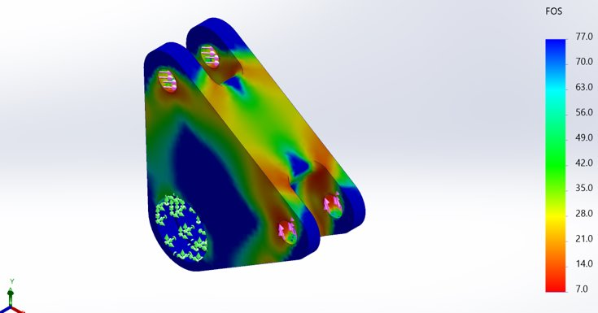

Figure B 6 – Pre-Topology Rear Rocker Factor of Safety Plot, Multi-Angle
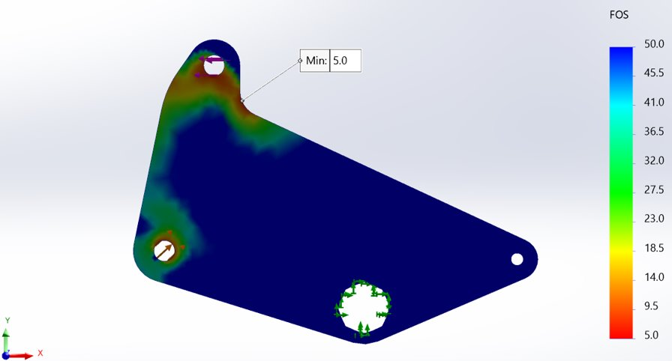
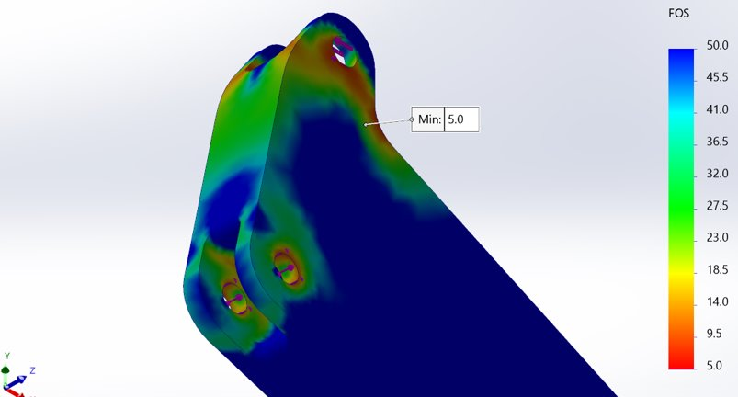 | 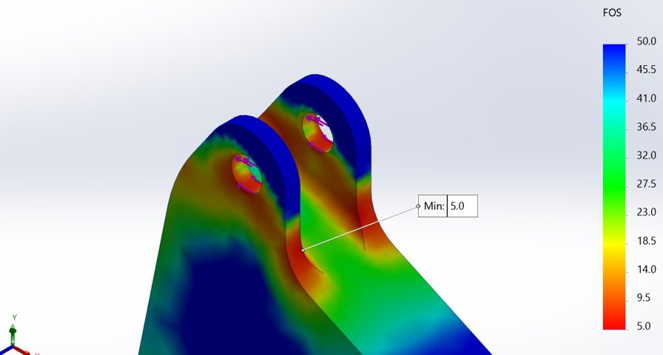

Figure B 7 – Mesh Settings
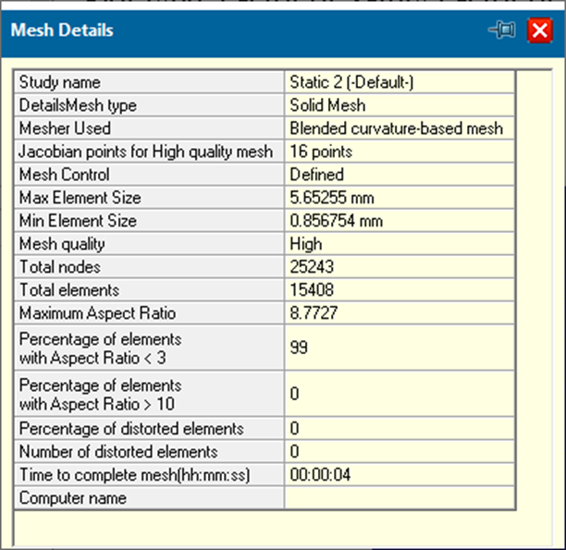
`

Appendix C: Post-Topology Results
Figure C 1 – Post-Topology Front Rocker Stress Plot, Multi-Angle
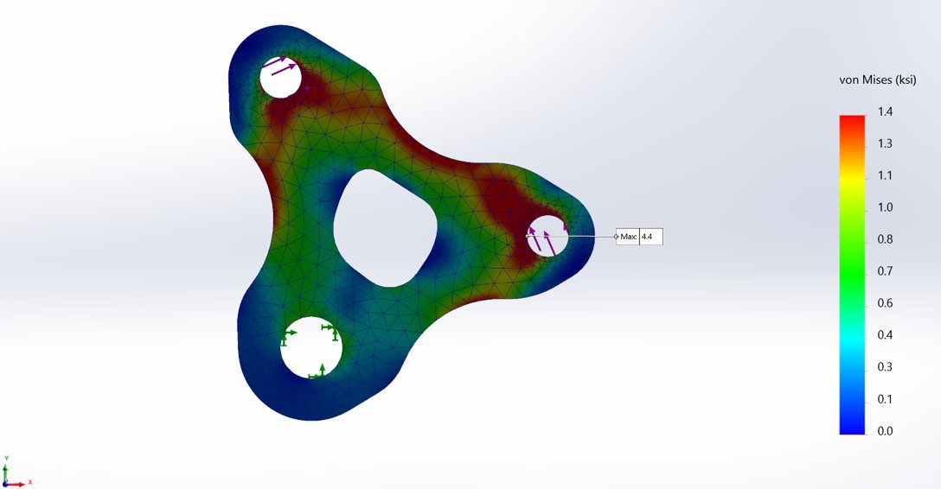
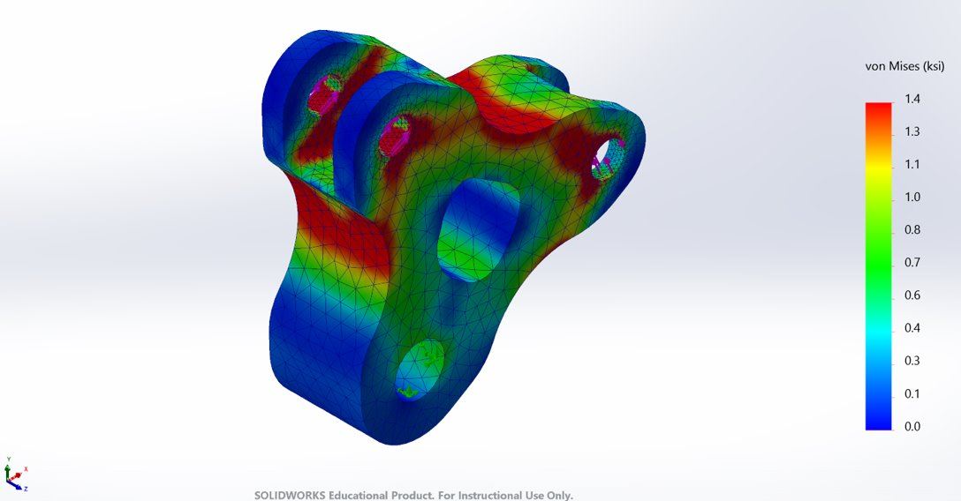 | 0 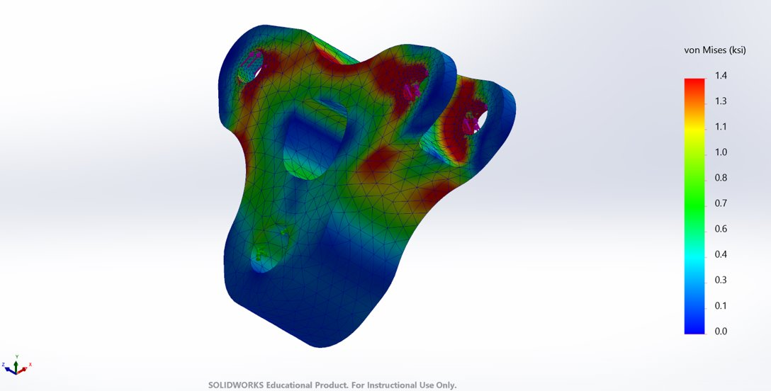

Figure C 2 – Post-Topology Rear Rocker Stress Plot, Multi-Angle
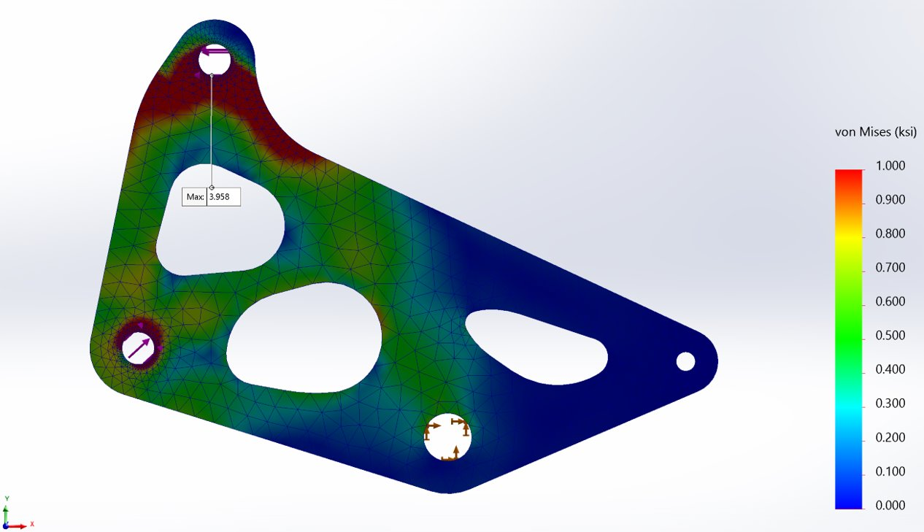
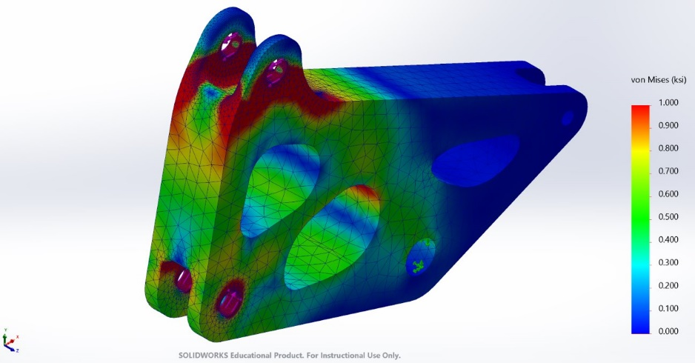 | 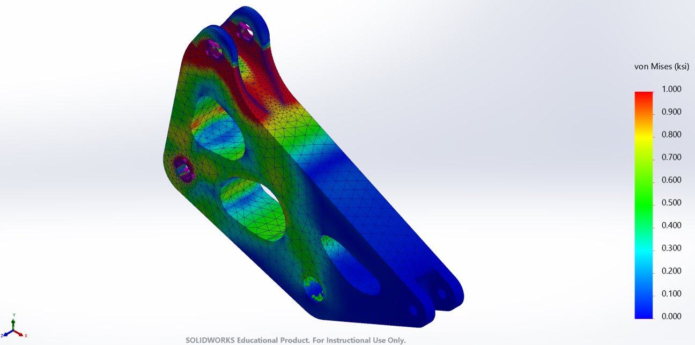

Figure C 3 – Post-Topology Front Rocker Displacement Plot
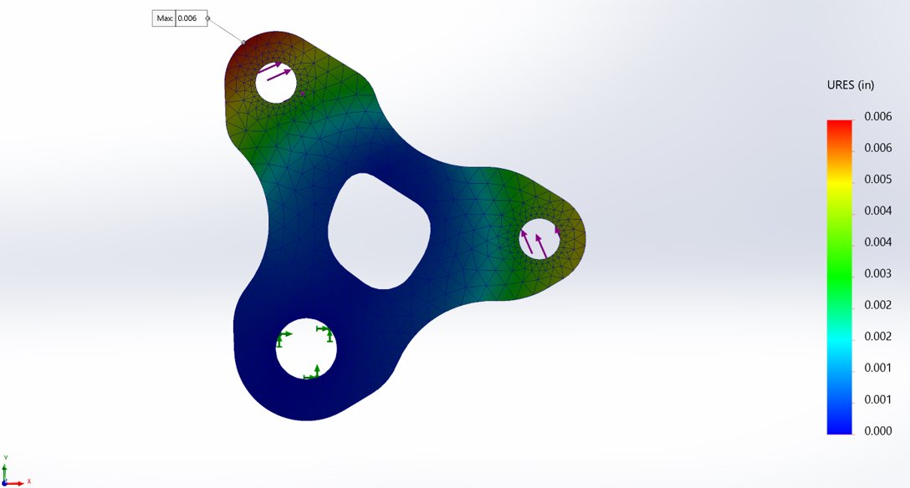
Figure C 4 – Post-Topology Rear Rocker Displacement Plot
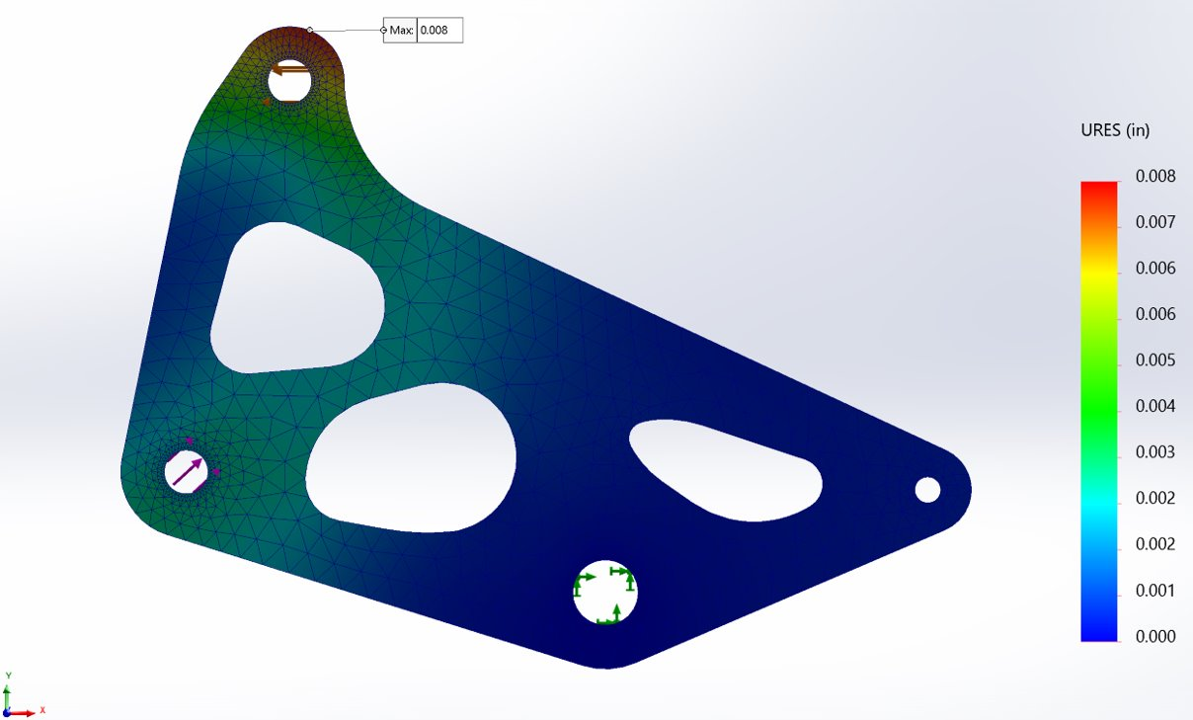
Figure C 5 – Post-Topology Front Rocker Factor of Safety Plot
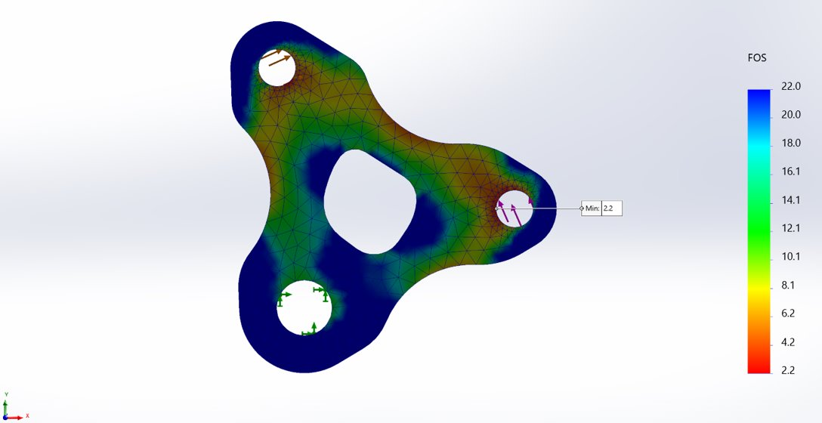
Figure C 6 – Post-Topology Rear Rocker Factor of Safety Plot
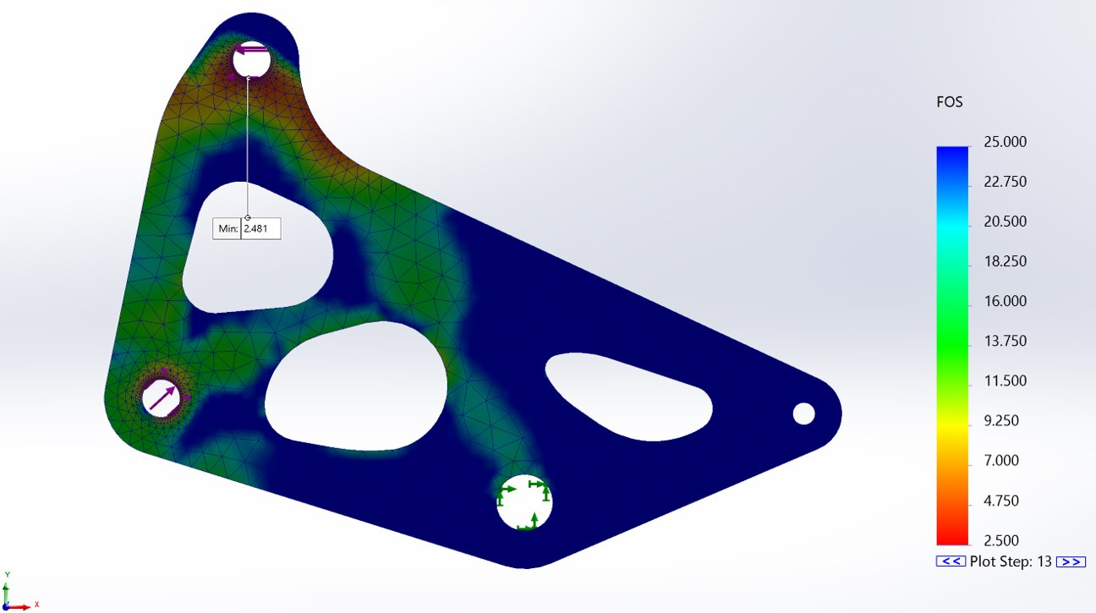
Figure C 7 – Post-Topology Model Dimensions
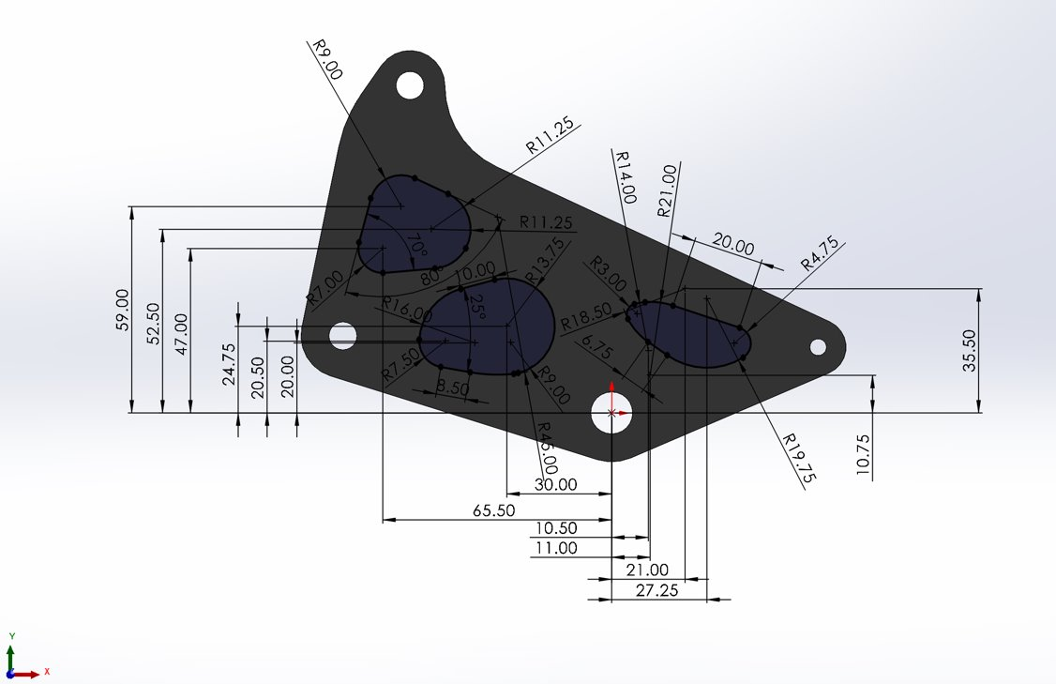

Figure C 8 – Mesh Settings
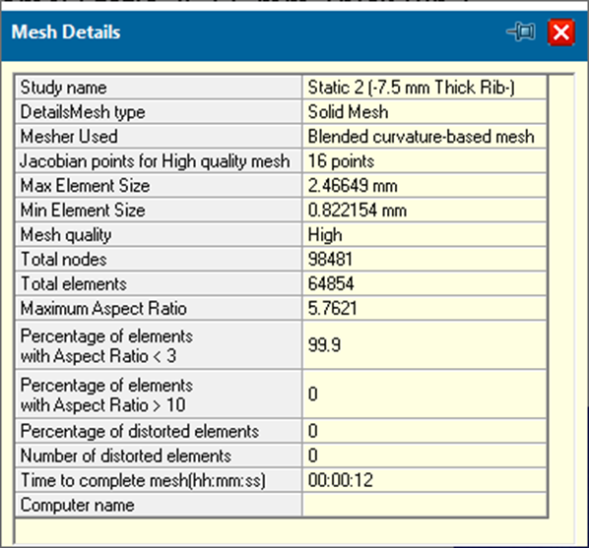

Appendix D: MTS 810 Machine Brackets and Dimensions
Figure D 1 – Rear Rocker Test Bracket Set-Up
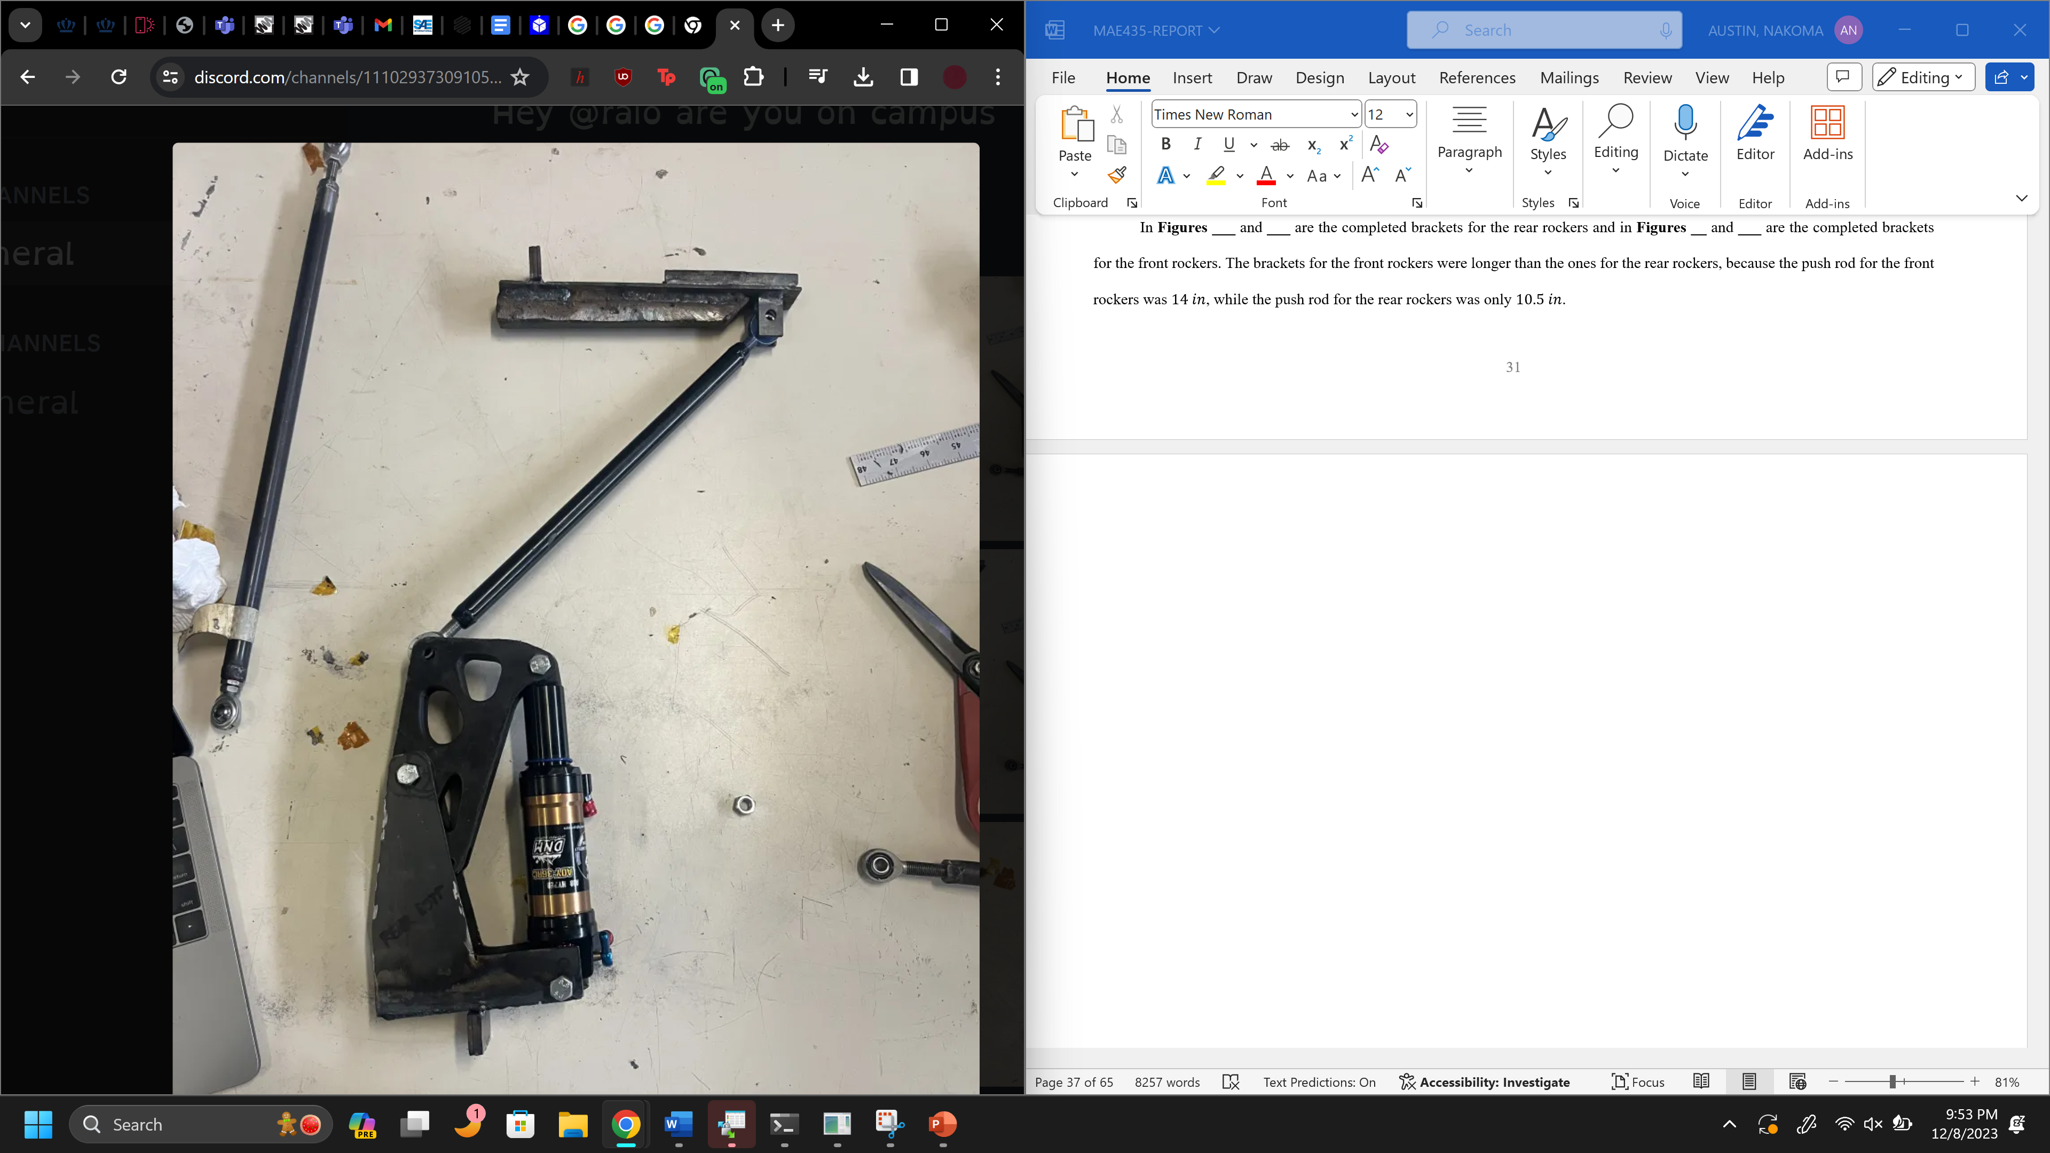
Figure D 2 – Front Rocker Test Bracket Set-Up
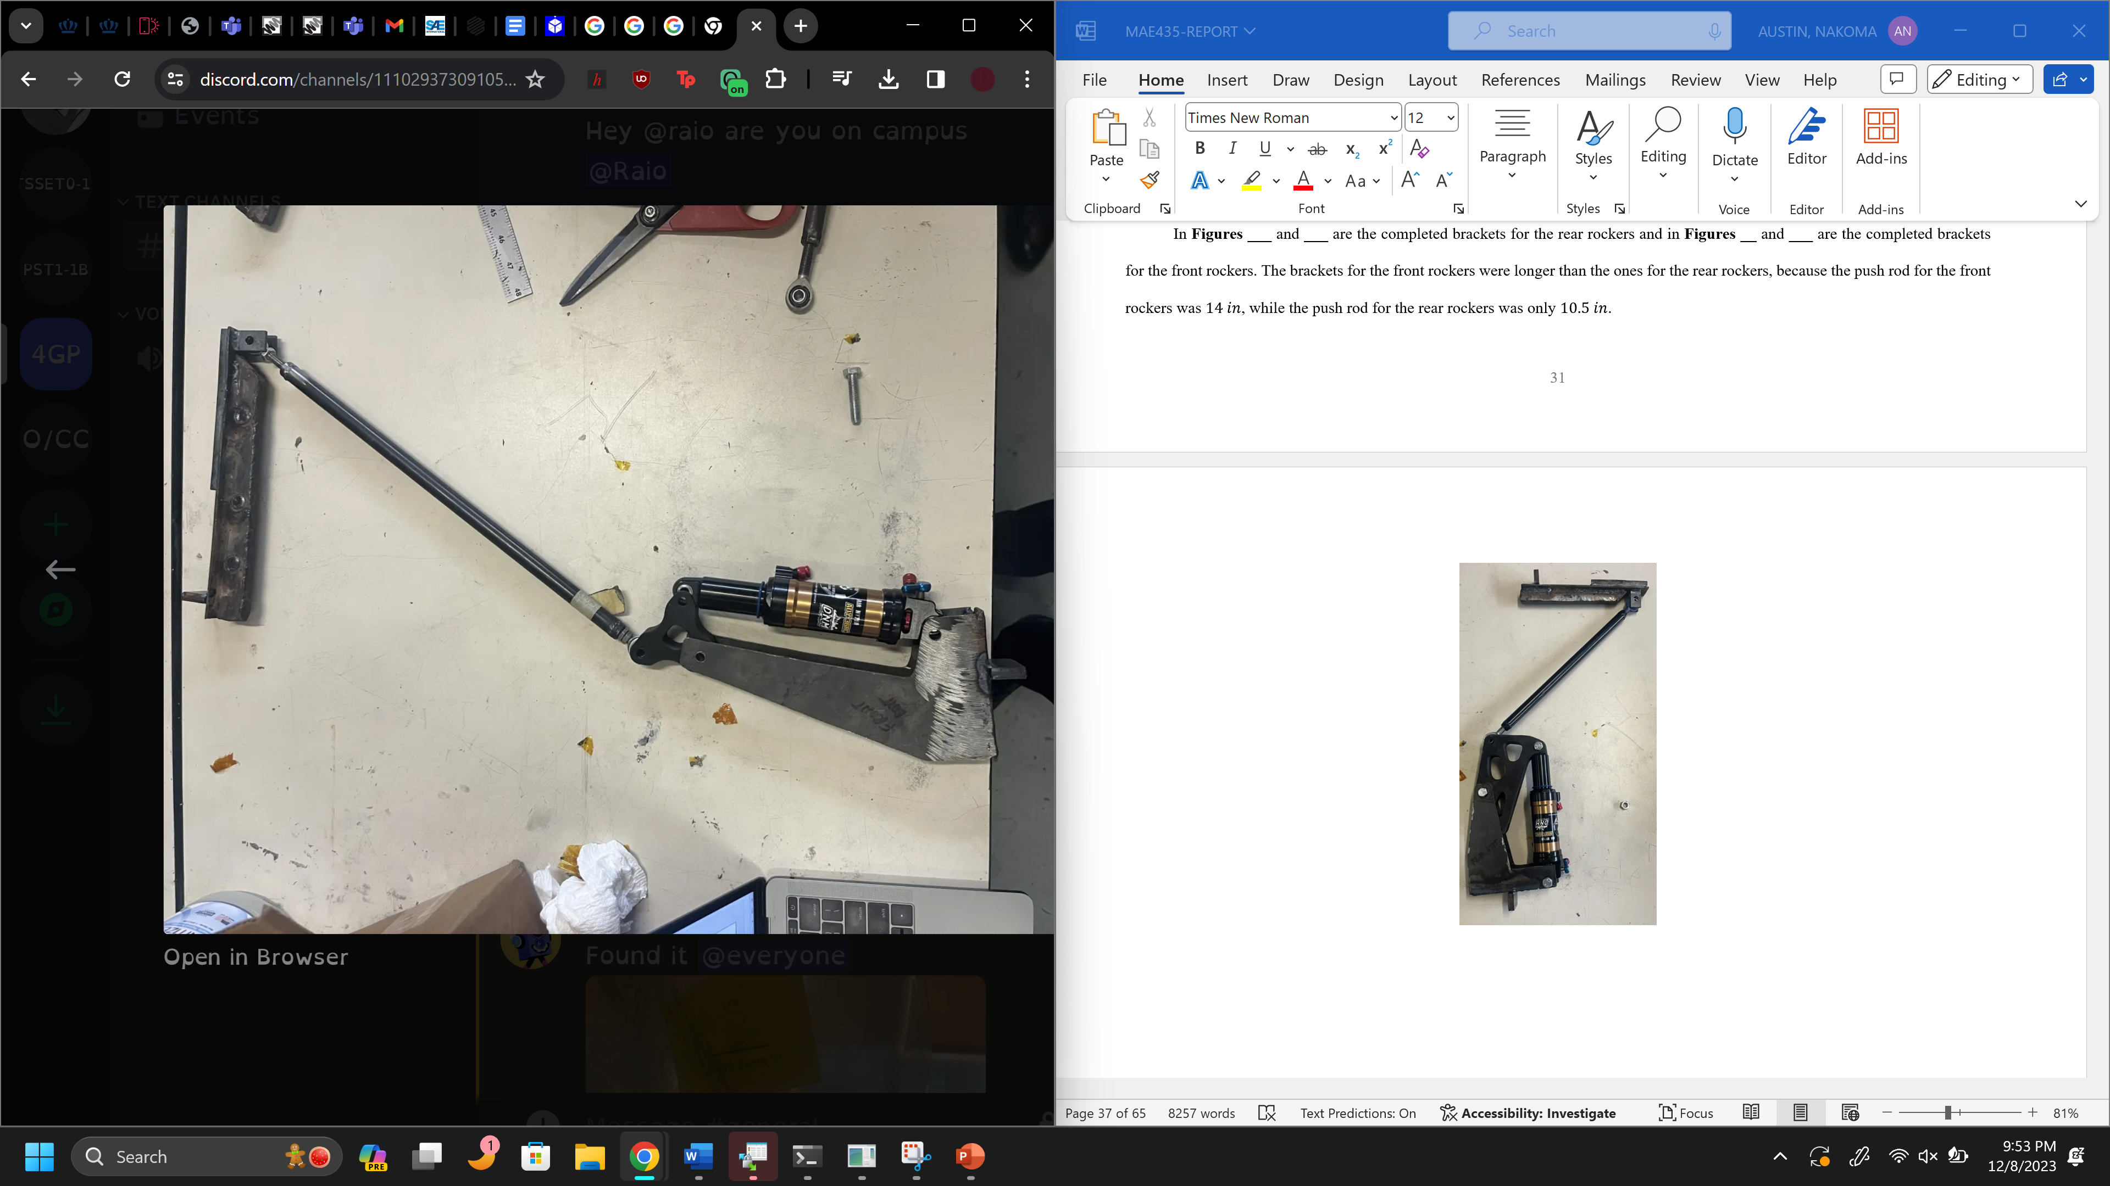
Figure D 3 – PA6-CF Rear Rocker with Brass Bearing
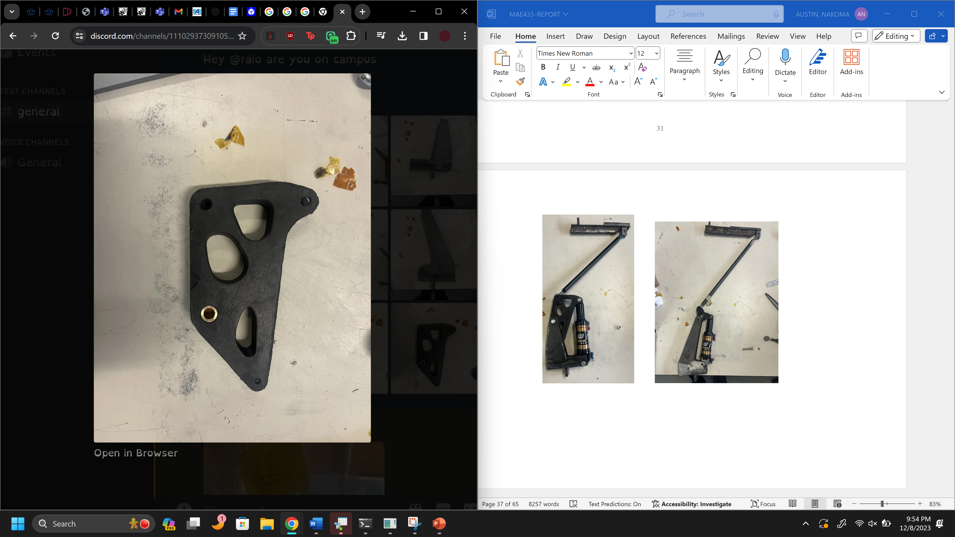
Figure D 4 – PA6-CF Front Rocker with Brass Bearing
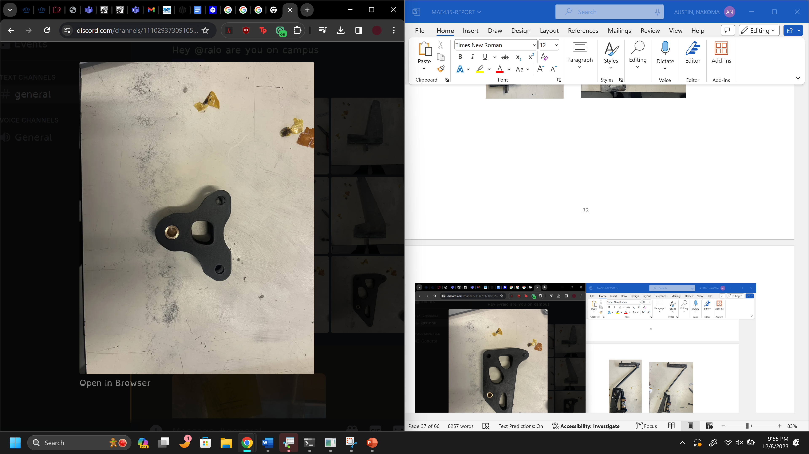

Figure D 5 – Rear Rocker Bottom Bracket Dimensions
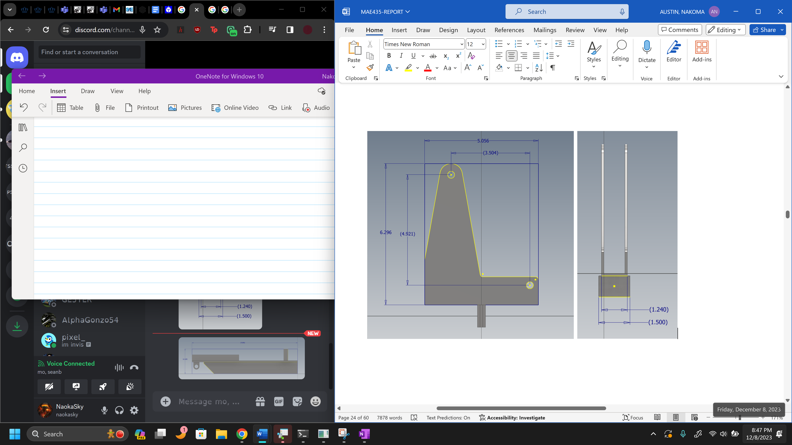

Figure D 6 – Rear Rocker Top Bracket Dimensions
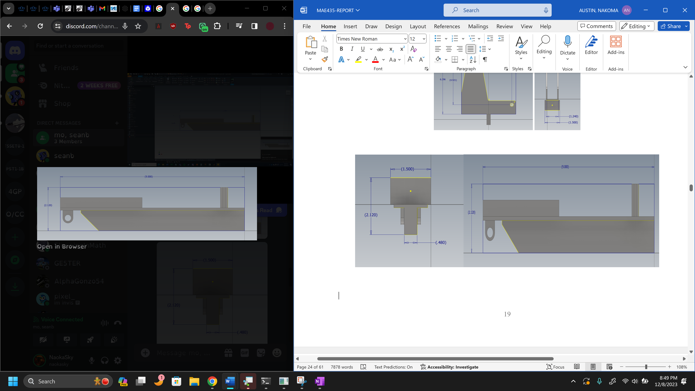
Figure D 7 – Front Rocker Bottom Bracket Dimensions
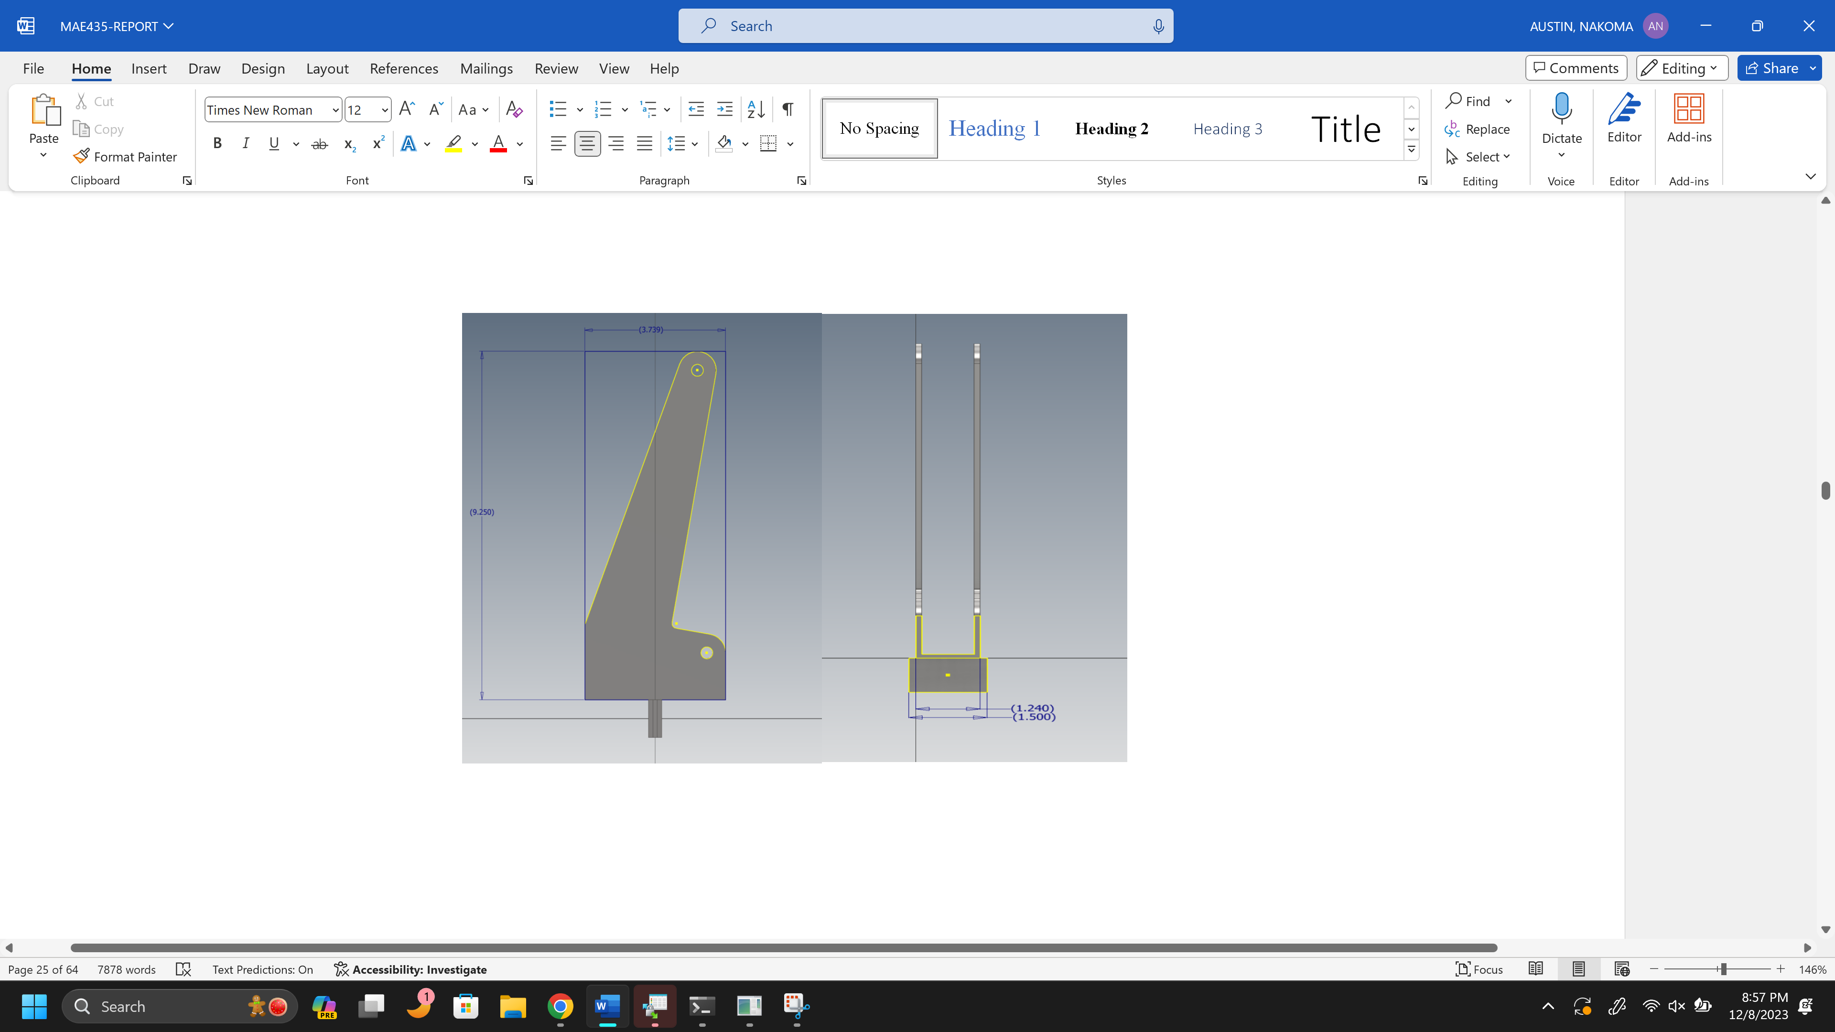

Figure D 8 – Front Rocker Top Bracket Dimensions
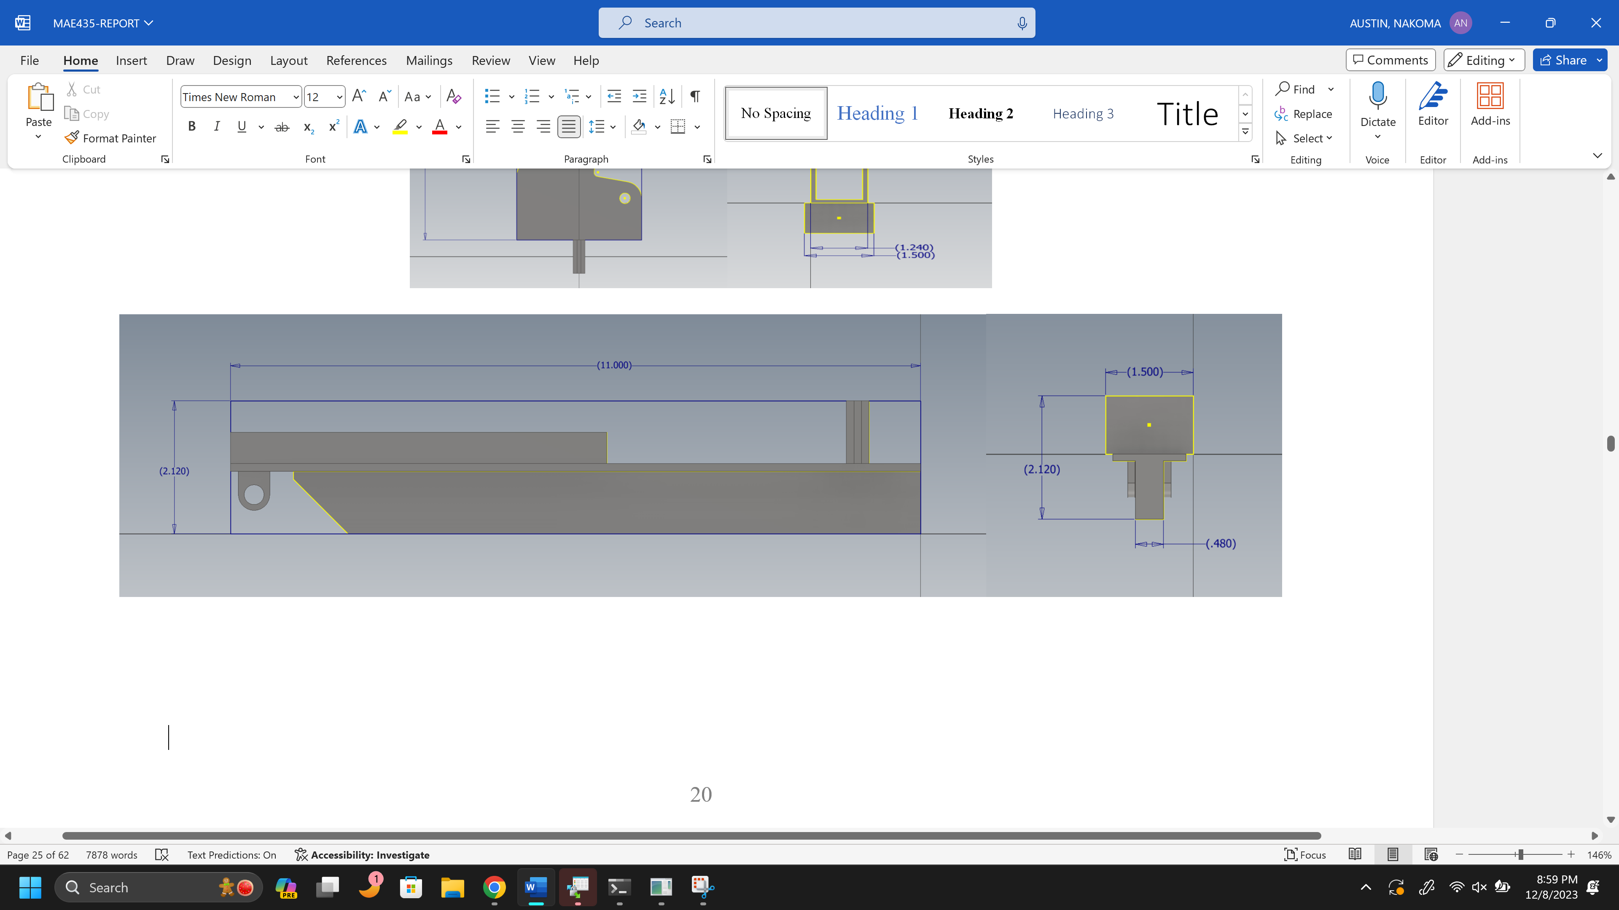

Appendix E: Gantt Chart
Figure E 1 – Gant Chart Summer 2023
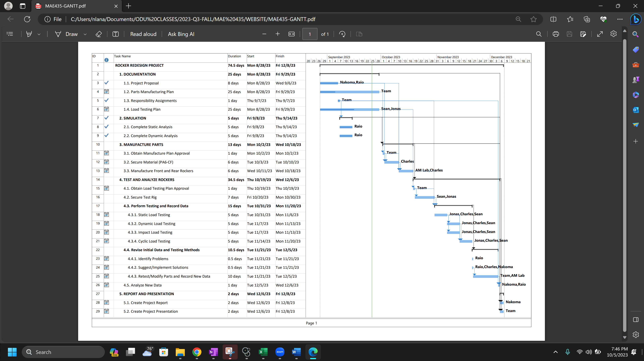

Figure E 2 – Gantt Chart Fall 2023
